What We Can Learn from the Remarkable (Mis)Alignments at Dahshur

By Glen Dash, Glen Dash Foundation for Archaeological Research

The north facing entrance passageway of the Bent Pyramid at Dahshur, also known as the north descending passageway, is aligned to due north with an accuracy of 30 seconds of arc, or 1/120 of one degree. (Dorner 1986, 42) [1] That’s about the width of a finger viewed from across a football field, and represents an achievement in surveying that would not be equaled for another four thousand years. (Brahe 1602) How the Egyptians did it, and why, is one important question Egyptologists have sought to answer. Beyond that though, there is another mystery here: Why does it seem as if the rest of the Bent Pyramid was deliberately misaligned with its entrance passageway?

[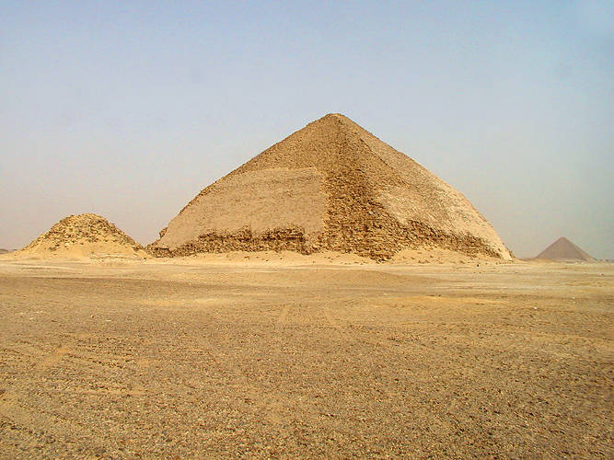](http://glendash.com/blog/wp-content/uploads/2014/10/01_bent_red_satellite.jpg)

**Figure 1: The Pyramids of Snefru at Dahshur. The Bent Pyramid is in the foreground. The Red Pyramid, two kilometers distant, is in the background. (Photo by Jon Bodsworth)**

King Snefru’s workmen began the construction the Bent Pyramid by digging a T-shaped trench into the clay and desert gravel at Dahshur (Figure 1). From the air, the excavation must have looked something like the remains of the pyramid of Djedefre at Abu Roash as we see it today (Figure 2). The north-south Djedefre entrance passageway descends to meet an east-west aligned burial chamber. Framing both the passageway and the tomb chamber is the pyramid’s base.

[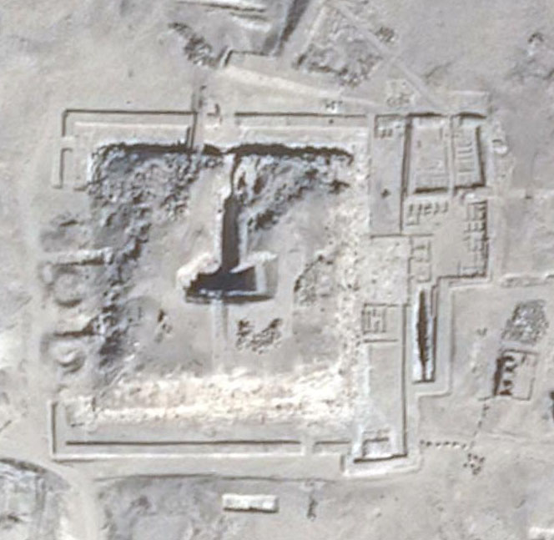](http://glendash.com/blog/wp-content/uploads/2014/10/Abu-Roash.jpg)

**Figure 2: Pyramid Internals. The pyramid at Abu Roash, denuded of its casing and most of its core, reveals its descending passageway and tomb chamber. (Photo courtesy Google Earth)**

Once the workmen building the Bent Pyramid had finished roughing out the descending passageway and the tomb chamber, the next task was aligning the whole complex with cardinal points. In the case of the north facing descending passageway, that was done by aligning it with the celestial pole. The Pyramid Texts tell us that that the descending passageway was intended to serve as a portal for the king’s spirit to travel to the celestial pole so he could “magistrate” among the “imperishable ones,” as the circumpolar stars were known. (Belmonte 2001, S5)

Among the methods the Egyptians could have used to align the passageway with pole, the best choice may have been the “pole star method” as proposed by Flinders Petrie. (Petrie 1883, 211-212) Petrie believed the Great Pyramid of Giza was aligned with due north using an arrangement similar to what we show in Figure 3. A plumb line is suspended from a north-south wall. An observer watches for the pole star to transit behind the plumb line from beyond a low bench which holds a moveable sight. [2] The purpose of the whole arrangement is to record the extreme movements of the pole star. Like all other stars of the northern hemisphere, the pole star circulates around the north celestial pole counterclockwise (Figure 4). Today, the pole star is Polaris, about one degree distant from the celestial pole. At the time the Great Pyramid was built, it was Thuban, about two degrees distant. As the pole star rotates around the north celestial pole, it passes sequentially through its highest point in the sky (“upper culmination”), its westernmost point (“western elongation”), its lowest point (“lower culmination”) and its easternmost point (“eastern elongation”).

[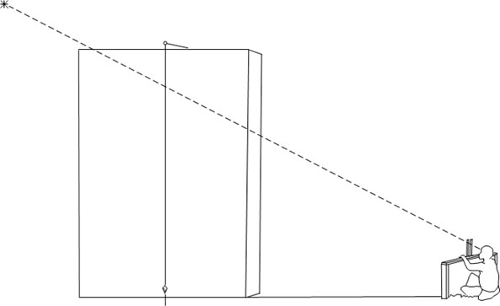](http://glendash.com/blog/wp-content/uploads/2014/10/pole-star-method-schematic.jpg)

**Figure 3: The Pole Star Method. A high masonry wall supports a plumb line which is affixed to the ground. An observer sights the star by adjusting his or her position and moving the sight until the star is occluded by the line. (Illustration by Joan Dash, drawing not to scale)**

[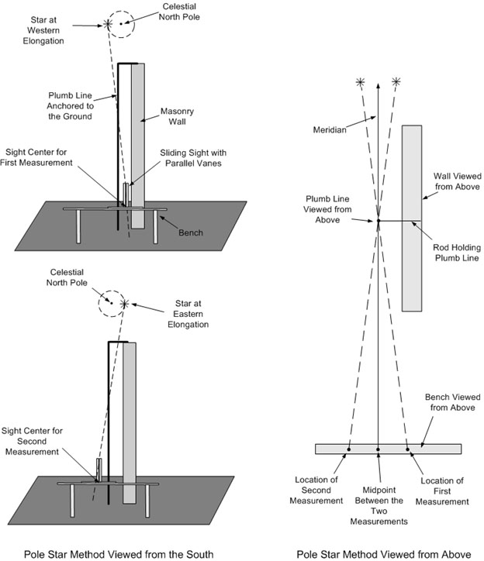](http://glendash.com/blog/wp-content/uploads/2014/10/pole-star-method-detail.jpg)

**Figure 4: Finding the due north. The pole star method requires two sightings, one at the star’s western elongation and one at its eastern. The location of the sight is marked on the bench after each sighting and the midpoint determined. The line connecting the midpoint and plumb line is due north. (Illustration by the author, drawing not to scale**)

To find due north, an observer views the pole star through the sight’s parallel vanes, tracking the movement of the star by adjusting the sight along the bench from east-to-west or west-to-east until the pole star disappears behind the rope. The star eventually reaches one of its elongations, and when it does, the observer marks the location of the center of the sight on the bench. The observer continues to watch until the pole reaches its other elongation and then marks that location as well. The observer then makes a third mark on the bench precisely between those two. A line drawn between this third mark and the rope should lie on the line connecting the observer to the North Pole, known as the meridian.

In the fall of 2012, I tested the pole star method at my home in Pomfret, Connecticut and found that the method could indeed be used to find the direction of due north to within a minute of arc. (Dash 2013, 11-12)

[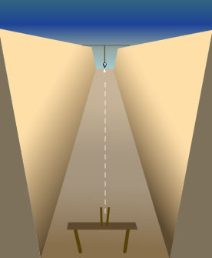](http://glendash.com/blog/wp-content/uploads/2014/10/Pole-star-and-trench.jpg)

**Figure 5: Pole star method and the descending passageway. A trench, such as the roughed out pyramid passageway shown here, makes the pole star method easier to use and more accurate. Instead of a long plumb line which might move in the wind, only a short one is needed, which is hung from the top of the trench. (Illustration by Wilma Wetterstrom, drawing not to scale)**

The fact that the descending passageway sloped upward actually made things easier. Instead of long plumb line extending from a high support to the ground, only a short plumb line hung from the top of the trench would have been needed (Figure 5). A shorter plumb line is more stable, reducing error. (Dorner 1998, 30) Once the Egyptians had determined the direction of due north, they could have scribed a line down the center of the roughed-out passageway and used it as a guide for laying in the passageway’s finish masonry.

With the direction of due north precisely identified, it should have been a simple matter to align the burial chamber east-west. All the Egyptians needed to do was to accurately turn a right angle. Judging from the precision of their masonry that should not have been a problem. But at the Bent Pyramid they did not. The tomb chamber and the descending passageway are curiously off angle.

The deviation was first noted by Josef Dorner, an Austrian archaeologist who noted the same thing at the nearby Red Pyramid. Dorner wrote, “This [deviation from a right angle] was certainly planned, for it must have been noticeable when the eastern wall of the descending passageway was placed adjacent [to the tomb chamber entrance] and a correction would have still been readily possible.” Dorner concluded that the descending passageway and the tomb chamber were “set independently … in a separate measurement process.” He also noted that the bases of the two pyramids appear to have been aligned with their tomb chambers, and in the case of both pyramids were off of due east-west by eight to nine minutes or arc. (Dorner 1998, 30)

Why would the Egyptians have performed two different measurements when only one was needed? The answer might be found, once again, in the Pyramid Texts.

The Texts make it clear that the whole purpose of a pyramid complex was to serve as a resurrection machine. (Allen 2003, 27) Egyptian beliefs concerning the afterlife were complex, but they drew inspiration from the daily cycle of the Sun. The Sun, born at dawn, arced across the sky and met its death at sunset. At night, the Sun entered the Goddess Nut, moved through her body, and was reborn at dawn. [3] The Texts suggest that the dead king followed a similar path in the afterlife. Each day after sunset, the king’s soul, its ba, entered the tomb chamber from the west and reunited with the king’s body. The sarcophagus served a role analogous to Nut’s womb. (Allen 2003, 26) The ba met the king’s life-force, the ka, and arose as the ahk, or “effective being.” The ahk left the tomb chamber and passed through a false door on the east side of the pyramid to join with the morning Sun. Together the two then arced across the sky over the course of the day, only to repeat the cycle after sunset. (Allen 2003, 26)

To fulfill its role in the resurrection, the pyramid complex needed to be linked to the Sun. The second measurement may have served that purpose by physically aligning the tomb chamber and the pyramid’s base with the Sun, while leaving the descending passageway connected to the stars.

One method the Egyptians might have used to link the complex with the Sun was the “Indian circle method,” so named because it was known to have been used on the Indian subcontinent. The method is illustrated in Figure 6. An observer starts by setting a rod, known as a gnomon, vertically in the ground. As the day passes, the shadow produced by the gnomon is tracked by the observer, who marks its position on the ground every few minutes, eventually producing a curve identified in Figure 6 as the shadow line. At the end of the day, the observer fixes a string to the rod and draws a circle which intersects the shadow line at two points. In theory, a line drawn through those two points runs east-west.

[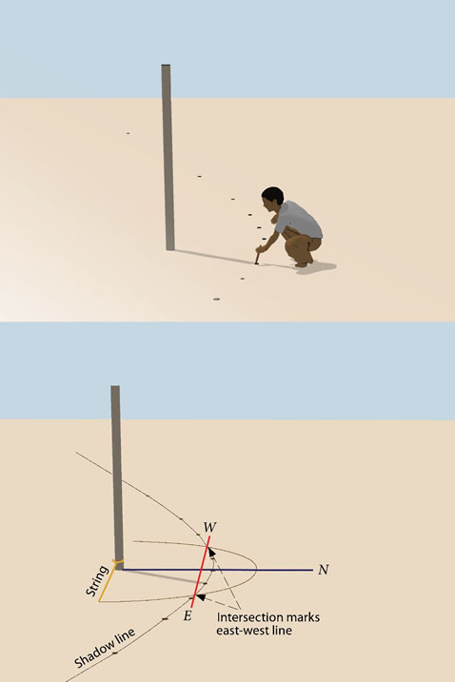](http://glendash.com/blog/wp-content/uploads/2014/10/Indian-circle-method.jpg)

**Figure 6: The Indian circle method. An observer marks the end of the shadow produced by the vertical rod over the course of a day. Connecting the points creates the shadow line. The observer then takes a string and draws a circle around the base of the rod. The circle intersects the shadow line at two points which lay on an east-west line. (Illustration by Wilma Wetterstrom)**

However, the Egyptians would have found it more difficult to precisely locate cardinal points using the Sun than the stars. For one, the gnomon’s shadow is diffuse and its exact location somewhat difficult to pin down. (Dash 2014, 4-5) For another, the date of the test matters. The Indian circle method is best performed on the solstices; near the equinox, the movement of the Earth relative to the Sun causes an additional error of five to six minutes of arc. [4] While the Egyptians could have used the pole star method to locate due north to within a minute of arc, they would have likely found the Indian circle method accurate to no better than three to eight minutes of arc depending on the time of year.

Today we tend to think of alignments as a purely mechanical art, but to the Egyptians, they might have been religious rites. By way of a solar method (accurate or not) the pyramid, the tomb chamber, and the spirit of the dead king could have been linked to the Sun. By way of a stellar alignment, he could have been eternally linked to the stars as well.

**Notes:**

[1] There are 60 arc seconds to an arc minute and 60 arc minutes to one degree.

[2] The Czech archaeologist Zbyněk Žába suggested the use of the bench, which makes the observer’s task easier. (Žába 1953, 70-71)

[3] The Egyptians concurrently held two visions of what happened to the Sun at night. In addition to passing through the body of Nut, the Sun could enter the netherworld (the Duat), merge with the mummy of Osiris and from that reunion be reborn. (Allen 2003, 24)

[4] The Earth’s tilt relative to the Sun is known as the Earth’s declination. Near the solstices, the Earth’s declination changes only a little from day to day. Near the equinoxes, the declination changes more rapidly. It is the change in declination during the course of a single day that causes the additional error.

**References:**

Allen, James, “Why a Pyramid? Pyramid Religion,” In The Treasures of the Pyramids, Zahi Hawass ed., (New York: Barnes and Noble Books, 2003), 22-27.

Belmonte, Juan Antonio, “On the Orientation of Old Kingdom Pyramids,” Archaeoastronomy, Vol. 26 (2001), S1-S20.

Brahe, Tycho, “Quadrans Volubilis Azimuthalisi,” Astronomiæ instauratæ Mechanica, (Noribergæ: apud L. Hulsivm, 1602).

Dash, Glen, “How the Pyramid Builders May Have Found Their True North,” Areagram, Vol. 14 No. 1 (Spring 2013), 8-14.

Dash Glen, “Did the Egyptians Use the Sun to Align the Pyramids?” <http://glendash.com/archaeology/working-papers.html>, Accessed October 1, 2014.

Dorner, Josef, “Form und Ausmaße der Knickpyramide” Mitteilungen des Deutschen Archäologischen Instituts, Abteilung Kairo, Vol. 42 (1986), 43-58.

Dorner, Josef, “Neue MesSungen an der Roten Pyramide,” In Stationen: Beiträge zur Kulturgeschichte Ägyptens, Rainer Stadelmann, Heike Guksch and Daniel Polz eds., (Mainz: Von Zabern, 1998), 23-30.

Petrie, W. M. Flinders, The Pyramids and Temples of Gizeh**,** (London: Field and Tuer, 1883).

Žába, Zbyněk, L’Orientation Astronomique Dans L’Ancienne Égypte, Et La Précession De L’Axe Du Monde, Prague: Czechoslovak Academy of Sciences, 1953.