A Dash of Maxwell’s

A Maxwell’s Equations Primer

Chapter VI – The Method of Moments

By Glen Dash, Ampyx LLC, GlenDash at alum.mit.edu
Copyright 2000, 2005 Ampyx LLC

The Method of Moments has become one of the most powerful tools in the RF engineer’s arsenal. In this chapter, we make the transition from theory to practice, first by attempting to compute the characteristics of a “short dipole” by hand, and then by demonstrating that a computer can do that in just a few seconds.

In our last article, we calculated the emissions from a “short current element” (Figure 1). The far field emissions were:

$$\begin{aligned}H_{φ}=\frac{1}{4π}I^{}ℓ\text{sin}θ\left(\frac{jω}{\text{cr}}\right) \\ E_{θ}=\frac{1}{4πε_{0}}I^{}ℓ\text{sin}θ\left(\frac{jω}{c^{2}r}\right)\end{aligned}$$

Where:

H_{φ} = Magnetic field in the φ direction (A/m)
E_{θ} = Electric field in the θ direction (V/m)
I* = The “retarded current,” I*= I₀ e^{j(ωt-βr)}
r = Distance from the current element to our observation point in meters
l = Length of current element in meters
ω = Frequency in radians per second = 2πf
c = Speed of light (m/s)
ε₀ = Permittivity of free space

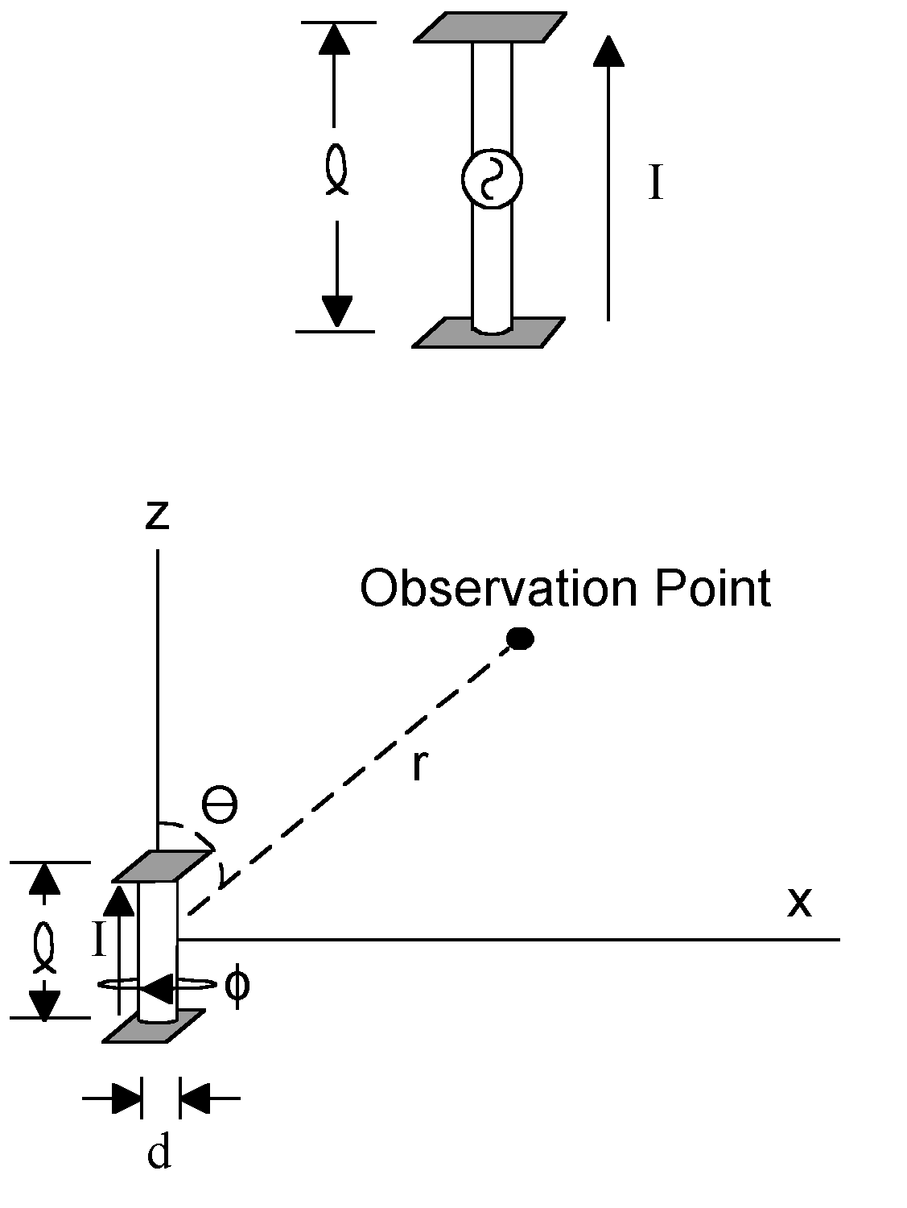
Figure 1 The starting point for our analysis is the short current element shown. It is a small, center driven antenna (small, that is, compared with the wavelength) loaded with plates at its ends. This produces a radiating element whose current distribution is relatively constant over its length.

The “short current element” differs from the “short dipole” in that the current element has constant current along its length. In contrast, the short dipole has no plates and consequently its current varies from a maximum at the center (where the drive is) to a minimum at its ends.

We will use the current element, however, to calculate the characteristics of the short dipole. To this end, we divide the short dipole into segments, each with constant current. By knowing the characteristics of the short current element we should be able to calculate the characteristics of the short dipole, or any antenna for that matter, from superposition.

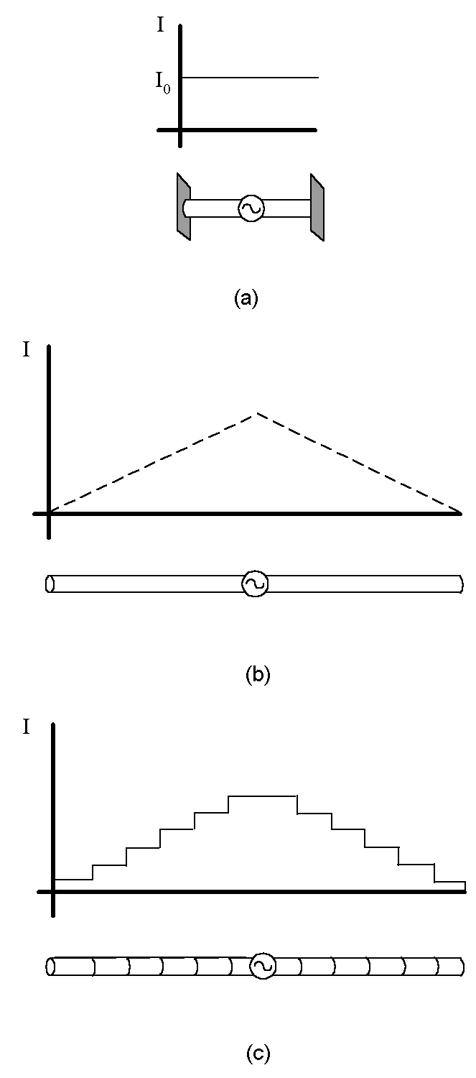
Figure 2: Our current element (a) has constant current along its length. For most antennas the current varies along the length (b). Nonetheless, almost any antenna can be approximated by one made up of constant current elements in a piece-wise linear fashion as shown in (c).

To use the Method of Moments, we start with this now familiar equation:

$$\text{E=-}Δ\text{V-}\frac{\text{dA}}{\text{dt}}$$
Where:

E = Electric field in V/m
V = Voltage
A = The vector potential

In our last chapter we calculated the vector potential produced by a short current element aligned with the z axis. It was:

$$A_{z}=\frac{μ_{0}I^{}ℓ}{4πr}$$

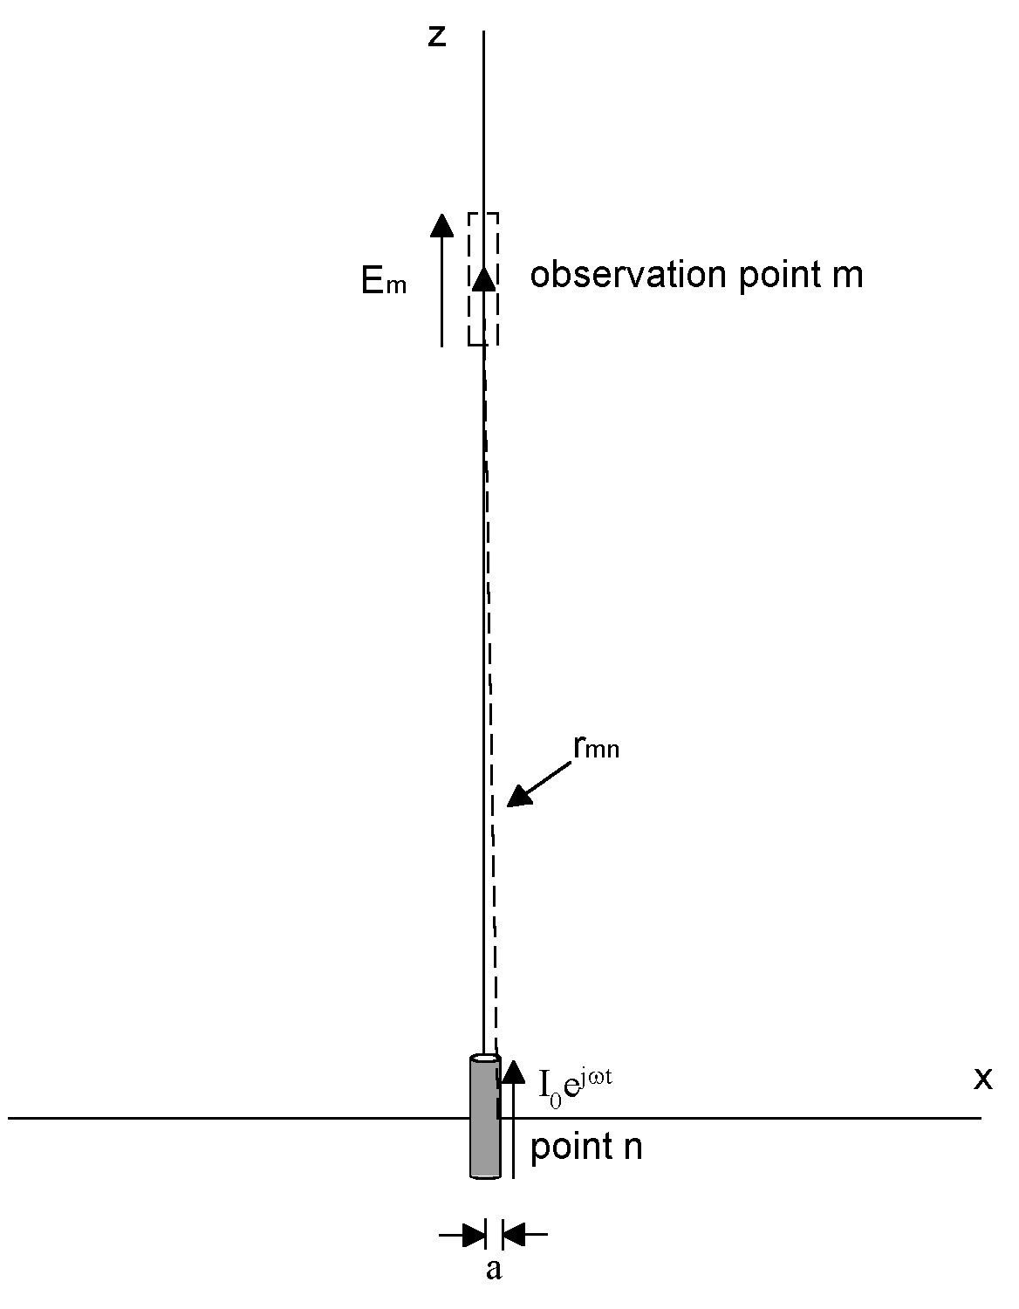
Figure 3 A current element at point n produces an electric field at observation point m. This field can be calculated using the vector potential.

The vector potential is aligned with the currents that produce it, Since our current element only has currents flowing in the z direction, the vector potential is also aligned in the z direction.

Our first task is to calculate the electric field produced at a given point along the z axis, say observation point m in Figure 3. Due to the “skin effect,” the current in the current element flows only in its outer skin. We will make the assumption that all the current in our current element is flowing in a filament placed a distance a from the z axis, a being the diameter of the current element (Figure 3).

At observation point m, the vector potential is:

$$A_{}=\frac{μ_{0}I^{}ℓ}{4π\sqrt{\left({\left(z_{m}−z_{n}\right)}^{2}+a^{2}\right)}}$$

Our next step is to relate the vector potential at observation point m to the electric field there. To do that, we need to explore once again what is meant by the vector potential.

The vector potential is a hypothetical construct, a mathematical tool. Because it is just a mental construct, we can define it any way we want. Fields can be defined by specifying their curl and their divergence. For the vector potential these are:

$$\begin{aligned}∇×A=B \\ ∇⋅A=−j{\text{ωμ}}_{0}ε_{0}V\end{aligned}$$

Having defined the vector potential, we can derive the electric field at observation point m as follows:

$$\begin{aligned}E_{m}=−ΔV−\frac{\text{dA}}{\text{dt}} \\ \frac{\text{dA}}{\text{dt}}\text{=j}ωA \\ Δ\text{V=}\frac{∂V}{∂z} \\ ∇⋅A=\frac{∂A}{∂z}=−j{\text{ωμ}}_{0}ε_{0}V \\ \frac{∂^{2}A}{∂z^{2}}=−j{\text{ωμ}}_{0}ε_{0}\left(\frac{∂V}{∂z}\right) \\ \frac{∂V}{∂z}=−\frac{1}{j{\text{ωε}}_{0}μ_{0}}\left(\frac{∂^{2}A}{∂z^{2}}\right) \\ E_{m}=\frac{1}{jωμ_{0}ε_{0}}\left(\frac{∂^{2}A_{}}{∂z^{2}}\right)−jωA_{} \\ E_{m}=\frac{1}{jωμ_{0}ε_{0}}\left(\frac{∂^{2}A_{}}{∂z^{2}}+β^{2}A_{}\right)\end{aligned}$$

The vector potential A is, in turn, a function of the current I. Therefore it should be possible to state the electric field at observation point m in terms of the current at point n. J. H. Richmond [4] has done that, calculating that it is equal to:

$$\begin{aligned}E_{m}=j\frac{\text{377}λ\left(\frac{Δz}{λ}\right)}{8π^{2}}\left(\frac{e^{−j2π\left(\frac{r}{λ}\right)}}{{\left(\frac{r}{λ}\right)}^{3}λ^{3}}\right)\left(\left(1+j2π\left(\frac{r}{λ}\right)\right)\left(2−3{\left(\frac{a}{r}\right)}^{2}\right)+4π^{2}{\left(\frac{a}{λ}\right)}^{2}\right)I\left(z_{n}\right) \\ E_{m}=X_{\text{mn}}I\left(z_{n}\right) \\ \text{Where: }X_{\text{mn}}=j\frac{\text{377}\left(\frac{Δz}{λ}\right)}{8π^{2}λ^{2}}\left(\frac{e^{−j2π\left(\frac{r}{λ}\right)}}{{\left(\frac{r}{λ}\right)}^{3}}\right)\left(\left(1+j2π\left(\frac{r}{λ}\right)\right)\left(2−3{\left(\frac{a}{r}\right)}^{2}\right)+4π^{2}{\left(\frac{a}{λ}\right)}^{2}\right)\end{aligned}$$

This field develops a voltage at observation point m equal to:

$$V_{m}=E_{m}Δz$$

Since V_{m} is a function of I(z_{n}), we can restate the voltage in terms of a “mutual impedance” Z_{mn}:

$$\begin{aligned}V_{m}=Z_{\text{mn}}I\left(z_{n}\right) \\ \text{Where: }Z_{\text{mn}}=j\frac{\text{377}{\left(\frac{Δz}{λ}\right)}^{2}}{8π^{2}λ}\left(\frac{e^{−j2π\left(\frac{r}{λ}\right)}}{{\left(\frac{r}{λ}\right)}^{3}}\right)\left(\left(1+j2π\left(\frac{r}{λ}\right)\right)\left(2−3{\left(\frac{a}{r}\right)}^{2}\right)+4π^{2}{\left(\frac{a}{λ}\right)}^{2}\right)\end{aligned}$$
Or alternatively,

$$\begin{aligned}Z_{\text{mn}}=j\frac{\text{377}{\left({Δz}_{λ}\right)}^{2}}{8π^{2}λ}\left(\frac{e^{−j2{πr}_{λ}}}{r_{λ^{3}}}\right)\left(\left(1+j2π\left(r_{λ}\right)\right)\left(2−3{\left(\frac{a}{r}\right)}^{2}\right)+4π^{2}{\left(a_{λ}\right)}^{2}\right) \\ \text{Where: }r_{λ}=\frac{r}{λ}\text{, }{Δz}_{λ}=\frac{Δz}{λ}\text{ and }a_{λ}=\frac{a}{λ}\end{aligned}$$

We now place a perfectly conducting metal wire of length Δz at observation point m. Being perfectly conducting, no voltage develops across it. This happens because the impressed field E_{m} causes current to flow in the conductor. This in turn causes a voltage drop across the segment’s self impedance, Z_{mm} . This voltage drop is just equal and opposite to the voltage caused by the impressed field E_{m} . Said another way:

$$\begin{aligned}V_{m(\text{internal})}+V_{m(\text{external})}=0 \\ V_{m(\text{internal})}=I\left(z_{m}\right)Z_{\text{mm}} \\ V_{m(\text{external})}=I\left(z_{n}\right)Z_{\text{mn}} \\ I\left(z_{m}\right)Z_{\text{mm}}+I\left(z_{n}\right)Z_{\text{mn}}=0\end{aligned}$$

Where:

I(z_{m}) = The current in the wire segment at point m
I(z_{n}) = The current in the segment at point n
Z_{mm} = The “self impedance” of the segment at point m
Z_{mn} = The mutual impedance between the segments at points m and n

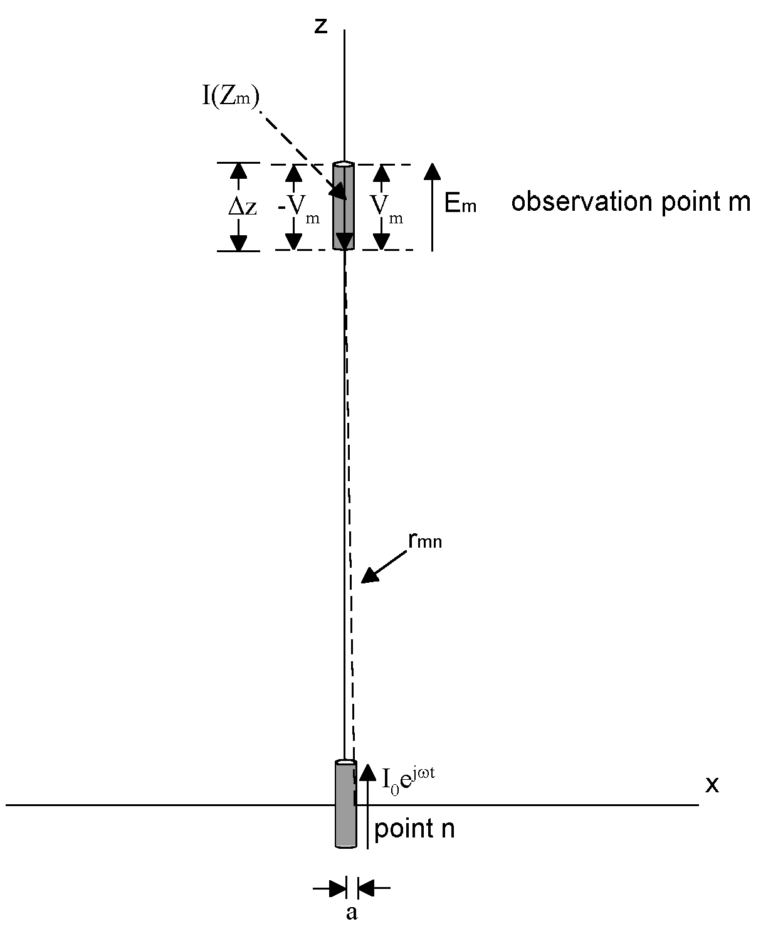
Figure 4: If we place a perfectly conductive wire at observation point m, it serves to “short out” the electric field produced by the current element at point n. This happens because the conductive wire produces its own field internally which offsets the electric field produced by the current element.

Extending the analysis to an antenna with N segments, each contributing to the field at observation point m, we have:

$$I\left(z_{1}\right)Z_{m1}+I\left(z_{2}\right)Z_{m2}+I\left(z_{3}\right)Z_{m3}⋅⋅+I\left(z_{N}\right)Z_{\text{mN}}=\sum_{n=1}^{n=N}{I\left(z_{n}\right)}Z_{\text{mn}}=0$$

We now consider the voltages on each one of the segments. Given N such segments, self and mutual impedances relate the current on each segment to the voltages on all others, forming a matrix:

$$\begin{aligned}I\left(z_{1}\right)Z_{\text{11}}+I\left(z_{2}\right)Z_{\text{12}}+I\left(z_{3}\right)Z_{\text{13}}+⋅I\left(z_{1N}\right)Z_{1N}=V_{1} \\ I\left(z_{1}\right)Z_{\text{21}}+I\left(z_{2}\right)Z_{\text{22}}+I\left(z_{3}\right)Z_{\text{23}}+⋅I\left(z_{2N}\right)Z_{2N}=V_{2} \\ I\left(z_{1}\right)Z_{\text{31}}+I\left(z_{2}\right)Z_{\text{32}}+I\left(z_{3}\right)Z_{\text{33}}+⋅I\left(z_{3N}\right)Z_{3N}=V_{3} \\ \\ \\ \\ I\left(z_{1}\right)Z_{N1}+I\left(z_{2}\right)Z_{N2}+I\left(z_{3}\right)Z_{N3}+⋅I\left(z_{\text{NN}}\right)Z_{\text{NN}}=V_{N}\end{aligned}$$

This matrix makes the Method of Moments possible. Once the mutual impedances are calculated the matrix can be solved and the currents on each of the segments determined. Once the currents on each segment are known, the total fields, both electric and magnetic, can be calculated by superposition.

We will use the Method of Moments to analyze a short dipole modeled (somewhat crudely) as consisting of three co-linear wire segments (Figure 5). Each segment is .033λ. All 3 together are .1λ. The diameter a equals .001λ. A voltage source equal to 1 volt is set in the center of Segment 2. Using the above analysis, we can state:

$$\begin{aligned}{ I}_{1}Z_{\text{11}}+I_{2}Z_{\text{12}}+I_{3}Z_{\text{13}}=0 \\ I_{1}Z_{\text{21}}+I_{2}Z_{\text{22}}+I_{3}Z_{\text{23}}{\text{=V}}_{0}=1 \\ { I}_{1}Z_{\text{31}}+I_{2}Z_{\text{32}}+I_{3}Z_{\text{33}}=0\end{aligned}$$

Only segment 2 has a voltage associated with it. All the other segments, being perfectly conducting and without sources, have no voltage associated with them.

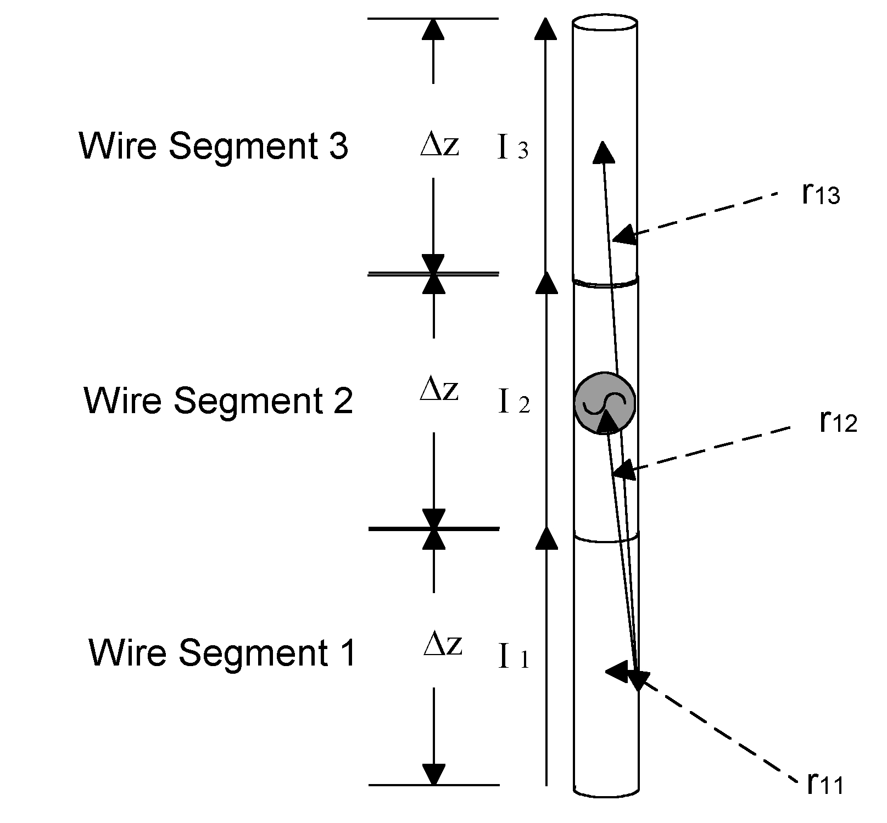
Figure 5: A small dipole is shown divided into three segments. Our first task in applying the Method of Moments is to calculate the self and mutual impedances of the segments.

Noting that Z₁₃ equals Z₃₁, we can calculate Z₁₃ by plugging in these numbers: r~.066λ, a=.001λ, λ=1, and Δz = .033λ. The result is:

$$\begin{aligned}Z_{\text{13}}=j\frac{\text{377}{\left({Δz}_{λ}\right)}^{2}}{8π^{2}λ}\left(\frac{e^{−j2{πr}_{λ}}}{r_{λ^{3}}}\right)\left(\left(1+j2π\left(r_{λ}\right)\right)\left(2−3{\left(\frac{a_{λ}}{r_{λ}}\right)}^{2}\right)+4π^{2}{\left(a_{λ}\right)}^{2}\right) \\ Z_{\text{13}}=j\frac{\text{377}λ^{2}{\left({Δz}_{λ}\right)}^{2}}{8π^{2}λ}\left(\frac{\text{cos}\left(2{πr}_{λ}\right)−j\text{sin}\left(2{πr}_{λ}\right)}{r_{λ^{3}}}\right)\left(\left(1+j2π\left(r_{λ}\right)\right)\left(2−3{\left(\frac{a_{λ}}{r_{λ}}\right)}^{2}\right)+4π^{2}{\left(a_{λ}\right)}^{2}\right) \\ {Δz}_{λ}=\text{.}\text{033} r_{λ}=\text{.}\text{066} a_{λ}=\text{.}\text{001} λ=1 \\ Z_{\text{13}}=j\frac{\text{377}{\left(\text{.}\text{033}\right)}^{2}}{8π^{2}}\left(\frac{\text{cos}\left(2π\left(\text{.}\text{066}\right)\right)−j\text{sin}\left(2π\left(\text{.}\text{066}\right)\right)}{{\left(\text{.}\text{066}\right)}^{3}}\right)\left(\left(1+j2π\left(\text{.}\text{066}\right)\right)\left(2−3{\left(\frac{\text{.}\text{001}}{\text{.}\text{066}}\right)}^{2}\right)+4π^{2}{\left(\text{.}\text{001}\right)}^{2}\right) \\ Z_{\text{13}}≈\text{.}\text{83}+j\text{39}\end{aligned}$$

Similarly, Z₁₂=Z₂₁=Z₂₃=Z₃₂ and, according to this formula, is equal to:

$$Z_{\text{12}}≈1\text{.}\text{02}+j\text{296}$$

For the “self impedances” Z₁₁=Z₂₂=Z₃₃ however, we run into a problem. The term r³ combined with the relatively long segment length makes the solution unstable. To deal with this, we could divide our short dipole into smaller segments. Choosing 11 segments for example, our matrix becomes:

$\begin{aligned}I\left(z_{1}\right)Z_{\text{11}}+I\left(z_{2}\right)Z_{\text{12}}+I\left(z_{3}\right)Z_{\text{13}}+⋅I\left(z_{1−\text{11}}\right)Z_{1−\text{11}}=0 \\ I\left(z_{1}\right)Z_{\text{21}}+I\left(z_{2}\right)Z_{\text{22}}+I\left(z_{3}\right)Z_{\text{23}}+⋅I\left(z_{2−\text{11}}\right)Z_{2−\text{11}}=0 \\ I\left(z_{1}\right)Z_{\text{31}}+I\left(z_{2}\right)Z_{\text{32}}+I\left(z_{3}\right)Z_{\text{33}}+⋅I\left(z_{3−\text{11}}\right)Z_{3−\text{11}}=0 \\ \\ \\ I\left(z_{1}\right)Z_{\text{61}}+I\left(z_{2}\right)Z_{\text{62}}+I\left(z_{3}\right)Z_{\text{63}}+⋅I\left(z_{6−\text{11}}\right)Z_{6−\text{11}}=1 \\ \\ \\ \\ \\ I\left(z_{1}\right)Z_{\text{11}−1}+I\left(z_{2}\right)Z_{\text{11}−2}+I\left(z_{3}\right)Z_{\text{11}−3}+⋅I\left(z_{\text{11}−\text{11}}\right)Z_{\text{11}−\text{11}}=0\end{aligned}$

But solving for all those variables will require a lot of computation, so it may be a good time to turn to our computers.

There are a number of very good computer programs that employ the Method of Moments.
We will use a program called EZNEC [2]. We input the same parameters as above, dividing our short dipole into 11 segments and setting λ equal to one meter. That is done by entering the data into the start screen (Figure 6). The frequency of 299.793 MHz is the equivalent of a one meter wavelength. We have chosen to place the wire in free space (the program has the option of simulating an antenna over earth). In the “Wires” dialogue box we enter the position of the one wire that makes up our short dipole, it starts at X=.05 meter, ends at X=-.05 meter and is .001 meter in diameter. Using the “Source” dialogue box, we place our 1 volt source in the middle of the wire.

A press of a button produces the results. The computer first computes the self and mutual impedances, then uses those impedances to solve for the currents on each of the segments. The magnitude and phase of these currents is tabulated in Figure 7. Once these are known, the fields can be computed by superposition.

The field pattern is plotted in Figure 7. Here, the “azimuth” field is displayed, which is the field in the X-Y plane. The pattern resembles a broad figure eight, typical of a dipole, even a short one. A host of other parameters are calculated including the impedance seen by the one volt source (2.081 –j1397 ohms). The antenna has a very low radiation resistance (2.081 ohms) and “looks” capacitive to the source (-j1397 ohms).

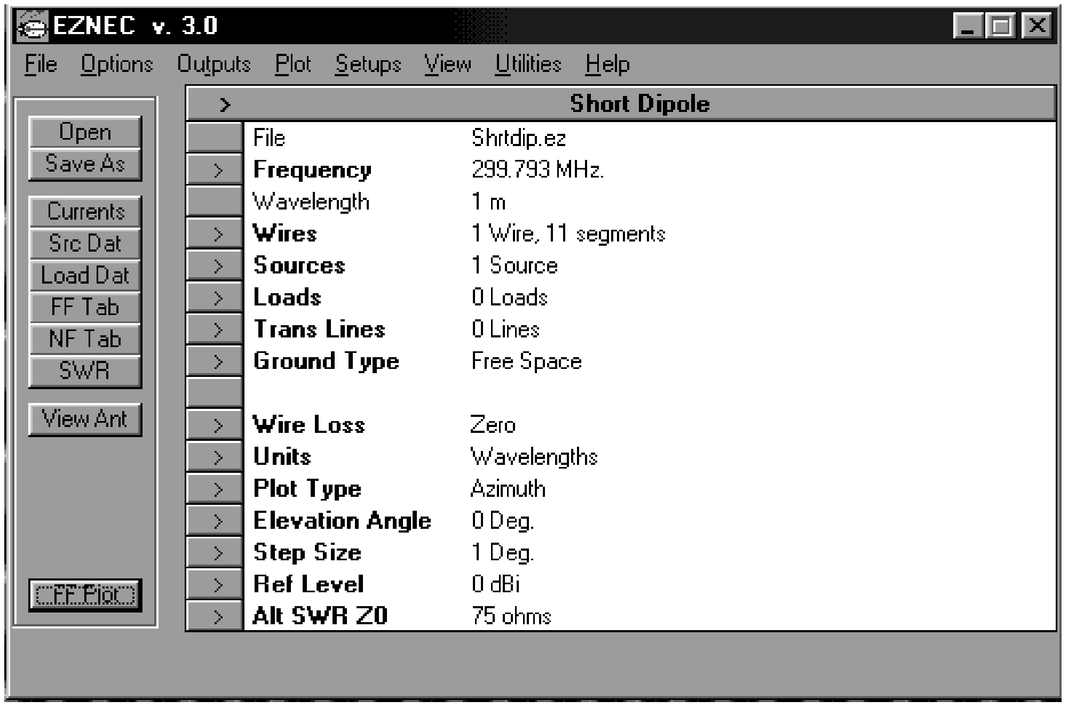
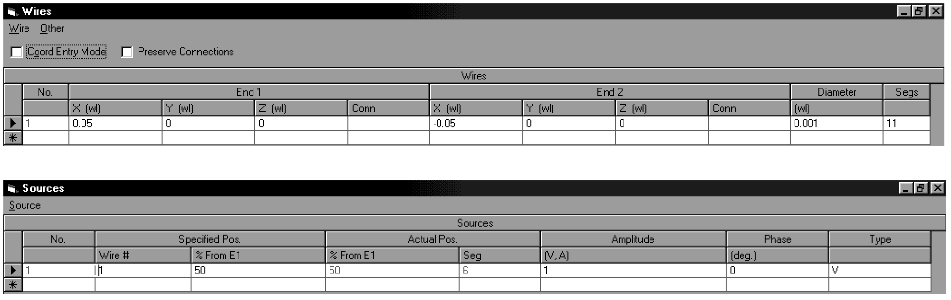
Figure 6: EZNEC opens with a screen that allows parameters such as the driving frequency, wire loss and type of ground to be entered. Separate dialogue boxes allow the antenna to be defined.
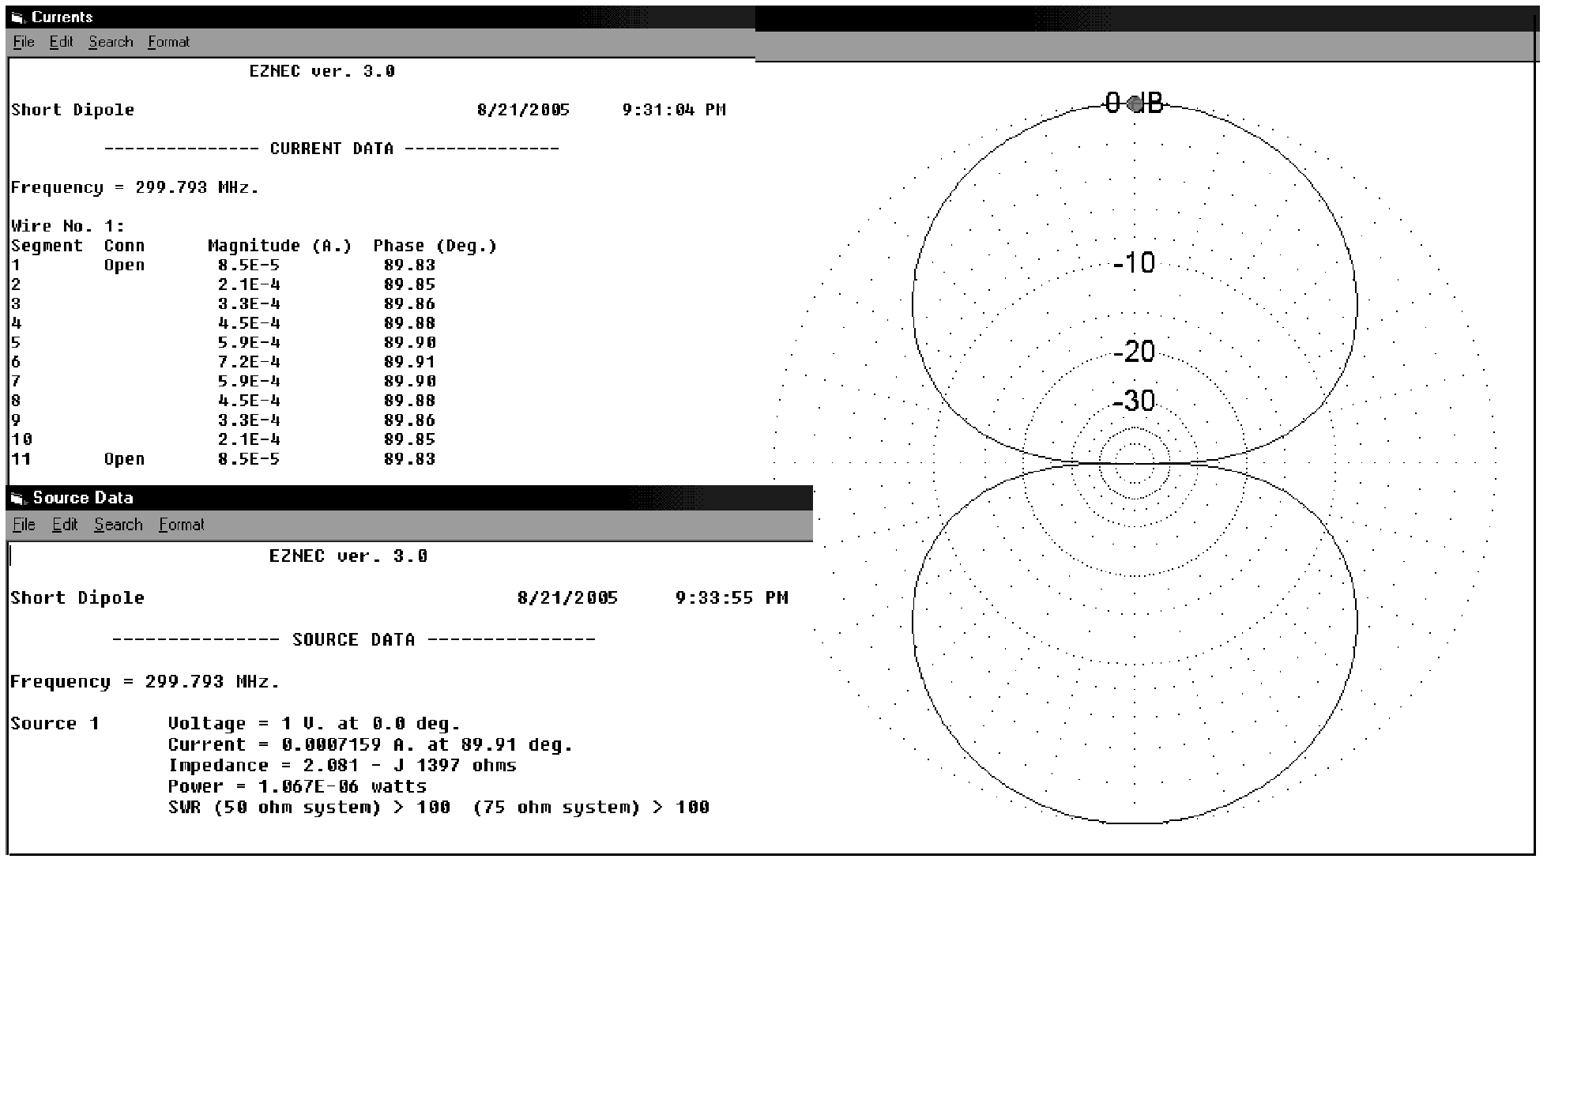
Figure 7: The output of EZNEC can provide the current on each segment, the fields generated, the pattern of the fields and such other parameters as the antenna’s impedance as seen from the source.

References:

- J. D. Kraus, Antennas, 2nd Edition, McGraw-Hill Inc., Pages 389-397.
- EZNEC, Version 3.0. EZNEC can be purchased from Roy Lewallen, W7EL, P.O. Box 6658, Beaverton, OR, 97007.
- H. C. Pocklington, “Electrical Oscillations in Wires,” Camb. Phil. Soc. Proc. Vol. 9, Page 324 (1897).
- J. H. Richmond, “Digital Computer Solutions of the Rigorous Equations for Scattering Problems,” Proc. IEEE Vol. 53, Page 796 (Aug. 1965).
- R. F. Harrington, Field Computation by Moment Methods, Macmillan Press (1968).
- R. F. Harrington, Field Computation by Moment Methods, Robert E. Krieger, Malabar, FL (1987).
- E. K. Miller and G. J. Burke, “Personal Computer Applications in Electromagnetics,” IEEE Ant. Prop. Soc. Newsletter, Aug. 1983, Page 5.
- D. M. Pozar, Antenna Design Using Personal Computers, Artech House (1985).
- J. K. Breakall, G. J. Burke and E. K. Miller, The Numerical Electromagnetics Code,” Lawrence Livermore National Lab., Document UCRL-90560 (1984).
- G. J. Burke, The Numerical Electromagnetics Code, SCEEE Press (1981).

Epilogue

Morphing Maxwell’s

In this series we hoped provide the reader with a roadmap to get from the place where an engineer typically starts – with a knowledge of circuits and math -- to the Method of Moments. A second aim was to help the engineer understand the technical papers written in the field. Such papers often start with some statement of Maxwell’s Equations in one of its various forms -- integral, differential, etc. -- without much introduction. We hope that that missing introduction can now be found here.

But there are some forms of Maxwell’s Equations that we did not touch on. So here, for good measure, are a few more:

We derived Maxwell’s Equations in what we called their ‘computational” form:

$$\begin{aligned}\text{E=-}(∇V+\frac{∂A}{∂t}) \\ \text{B=}∇×\text{A } \\ \text{V=}\frac{1}{4{\text{πε}}_{0}}\sum_{n=0}^{n=N}{\frac{ρ_{n}}{r_{n}}}{\text{ v}}_{n} \\ \text{A=}\frac{μ_{0}}{4π}\sum_{n=0}^{n=N}{\frac{J_{n}}{r_{n}}}{\text{ l}}_{n}{\text{ a}}_{n} \end{aligned}$$

But the equations can also be stated in this form, which relates the electric and magnetic fields to the scalar potential (voltage) and vector potential (A):

$$\begin{aligned}\text{E=-}(∇V+\frac{∂A}{∂t}) \\ \text{B=}∇×\text{A } \\ \text{V=}\frac{1}{4{\text{πε}}_{0}}\int_{v}{\frac{{ρe}^{−jβr}}{r}}∂\text{v } \\ \text{A=}\frac{μ_{0}}{4π}\int_{v}{\frac{{\text{Je}}^{−jβr}}{r}} ∂\text{v } \end{aligned}$$

We also discussed the definition of the vector potential, something that is made up and which we could have defined any way we wished. We chose to define it as:

$$\begin{aligned}∇×A=B \\ ∇⋅A=−j{\text{ωμ}}_{0}ε_{0}V\end{aligned}$$

For the “static” case, ω=0, so;

$$\begin{aligned}∇×A=B \\ ∇⋅A=0\end{aligned}$$

To derive an expression for the vector potential in term of currents, we used these equations:

$$\begin{aligned}∇^{2}V=−\frac{ρ}{ε_{0}} \\ ∇^{2}A=−μ_{0}J\end{aligned}$$

But these equations were for the static case. Where ω is not zero, these equations become:

$$\begin{aligned}∇^{2}V+μ_{0}ε_{0}ω^{2}V=−\frac{ρ}{ε_{0}} \\ ∇^{2}A+μ_{0}ε_{0}ω^{2}A=−μ_{0}J\end{aligned}$$

Finally, some technical papers will analyze phenomenon using what are known as Hertz vectors.
The Hertz vector (Π) is defined as:

$$\begin{aligned}A=μ_{0}ε_{0}\frac{dΠ}{\text{dt}} \\ Π=Π_{0}e^{jωt} \\ A=j{\text{ωμ}}_{0}ε_{0}Π\end{aligned}$$

Therefore any expression in terms of A can also be expressed in terms of the Hertz vector Π.

In a previous chapter we defined the divergence of the vector potential as being equal to zero. In that case, we were dealing with static fields, therefore ω=0.
In a milestone in the study of electromagnetic theory, H. C. Pocklington [3] published in 1897 what became known as Pocklington’s Equation. Each segment n along a wire aligned with the z axis contributes a vector potential element ∂ A_{z} : $$∂A_{z}=\frac{μ_{0}I\left(z_{n}\right)e^{−jβr}\text{dz}}{4πr}$$ Each differential element ∂A_{z} creates a differential element ∂E_{z} at an observation point m: $$\begin{aligned}∂E_{z}=\frac{I\left(z_{n}\right)}{j4{\text{πωε}}_{0}}\left(\frac{∂^{2}}{∂z^{2}}G_{\text{mn}}+β^{2}G_{\text{mn}}\right)\text{dz} \\ \text{Where: }G_{\text{mn}}=\frac{e^{−jβr}}{r_{\text{mn}}}\text{ and }r_{\text{mn}}=\sqrt{\left({\left(z_{m}−z_{n}\right)}^{2}+a^{2}\right)} \\ m=\text{observation point} \\ n=\text{source point}\end{aligned}$$ G is known as Green’s function. To find the total electric field at an observation point m, ∂E_{z} is integrated: $$E_{z}=\frac{1}{4πj{\text{ωε}}_{0}}\int_{{−L}/2}^{L/2}{\left(\frac{∂^{2}}{∂z}G_{\text{mn}}+β^{2}G_{\text{mn}}\right)}I\left(z\right)\text{dz}$$
In the last two decades the Method has been refined repeatedly and algorithms have become increasingly complex. Among other things, the programs no longer make the simple assumption that the current along each segment is constant. The Numerical Electromagnetics Code (NEC) developed by Lawrence Livermore National Laboratory for example uses a combination of sinewaves and cosines on each segment. Nonetheless, reduced to their basics, the programs all do what we have attempted to do here: calculate mutual impedances, use matrix calculations to solve for the currents on each segment and calculate fields by superposition.

