Experiments In EMC: How Common Mode Currents Are Created

By Glen Dash, Ampyx LLC, GlenDash at alum.mit.edu
Copyright 2000, 2005 Ampyx LLC

“I’ve all ready read the books on EMC and visited a lot of home pages... But all these references did not mention anything about the physical phenomenon that causes common mode currents... Are common mode emissions inherent in any physical system? Can I model them?”
--Overheard on the ‘Net

It’s by no means a trivial question. And, in spite of decades of hand waving by authors and consultants, the principal mechanism by which common mode currents are created in digital devices was not well understood until the decade of the 90s. In this article, we’ll explore the physics behind the creation of common mode currents, and perform some experiments to verify our understanding.

We begin with the simplest of circuits, a signal source driving 10 cm of 300 ohm twin lead shown in Figure 1. In one way or another, all wire line communication has as its goal transmitting signals faithfully from a source to a load. Here the load is matched to the line, and good fidelity can be expected. (Note that since the transmission line is matched to the load, there will be no reflection at the load end. Therefore, it is not necessary that the source be matched to the line.)

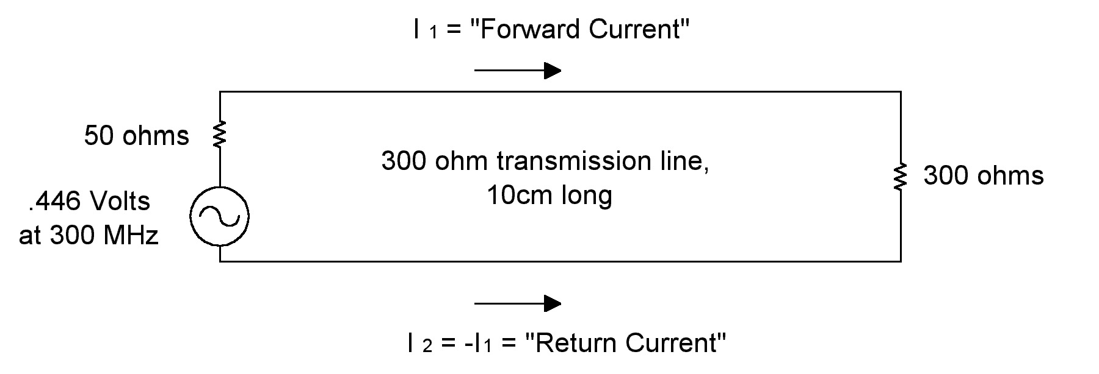
Figure 1: Our analysis starts with a simple circuit. A voltage source drives a short length of 300 ohm twin lead, terminated in a 300 ohm load.

The radiation that could be expected from the circuit in Figure 1 is relatively small. We can simulate the circuit on our Method of Moments simulator (Reference 1). It predicts the radiation at 3 meters for the circuit in Figure 1 to be approximately 1200 uV/m at 3m (in free space).

We will make the circuit a bit more challenging by adding two wires to the return path as shown in Figure 2. I₁, the “forward” current, will now be split at Node 2, some of it returning via the twin lead to the source, and some of it moving down the wire now attached at that node. Current moving down the added wire, which acts as an antenna, will partially be reflected back when it reaches the end of the wire, and partially radiated into space.

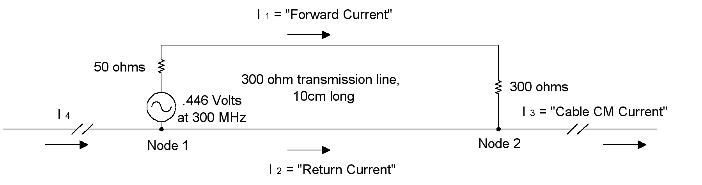
Figure 2: Adding wires to the return in Figure 1 create a more complicated circuit. Radiation increases dramatically because of common mode currents driving the wires attached.

Can I₃ be readily predicted? It can, using a few simplifying assumptions. Suppose the wire “antennas” of Figure 2 are resonant at the drive frequency, 300 MHz. These two wires will have the characteristic impedance of a dipole antenna at resonance: 73 ohms. Each “arm” of the antenna can be modeled as a resistance to earth ground of one half of that figure, or 36.5 ohms. The twin lead itself, being very much shorter than the wavelength, can be modeled electrically by the use of two inductors, L₁ and L₂ as shown in Figure 3. Each is approximately one half the total inductance of the loop shown in Figure 1. The formula for the inductance of a short strip of twin lead is well known and the inductance is approximately 140 nH. If we assume that half of this inductance can be assigned to L₂ , then this “partial inductance” L₂ is approximately 70 nH. Knowing that, we can readily calculate I₃ from the circuit model of Figure 3. We predict that I₃ =I₄ = 1.2 mA.

These currents are “common mode” currents. Here’s how common mode and differential currents are defined:

$$\begin{aligned}I_{1}=I_{\text{diff}}\text{ + }I_{\text{cm}} \\ I_{2}=−I_{\text{ diff}}\text{ + }I_{\text{ cm}}\end{aligned}$$

Where:

I _{diff} = Differential current
I _{cm} = Common mode current

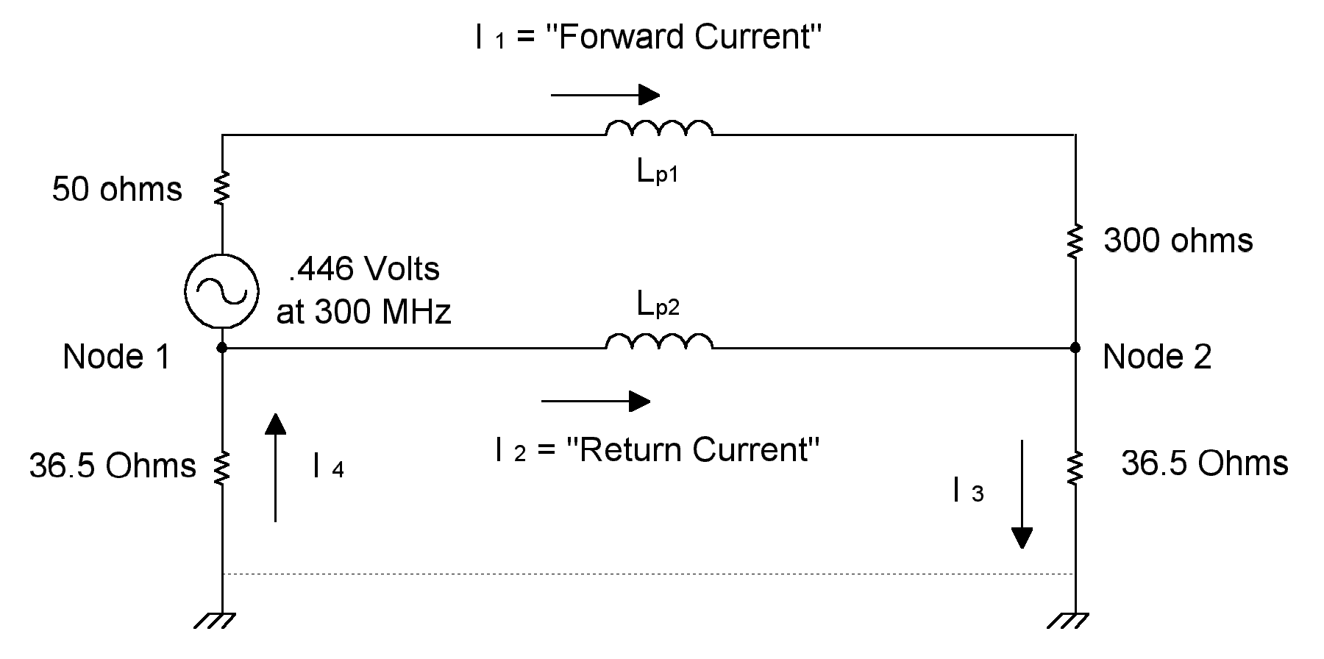
Figure 3: The radiation from the circuit in Figure 2 can be calculated using the circuit model of Figure 3. To calculate radiation accurately we will need to know the partial inductances of the forward and return conductors. The added wires of Figure 2 are assumed to be at resonance.

Rearranging terms, we find that:
$$\begin{aligned}I_{\text{diff}}=\frac{I_{1}−I_{2}}{2} \\ I_{\text{cm}}=\frac{I_{1}+I_{2}}{2}\end{aligned}$$

A loop’s differential and common mode currents are defined as follows. Since , by definition I _{1 diff} = -I _{2 diff} and I _{1 cm} = I _{2 cm}:

$$\begin{aligned}I_{3}=I_{1}+I_{2} \\ I_{3}=(I_{\text{ diff}}+I_{\text{cm}})+({−I}_{\text{ diff}}+I_{\text{cm}}) \\ I_{3}\text{=2 }(I_{\text{ cm}})\end{aligned}$$

Our Method of Moments program can be used to predict the radiation from the circuit of Figure 2. It is 27,500 uV/m at 3 m in free space, a gain of 27 dB over the circuit in Figure 1. Adding a couple of wires to the return of Figure 1 increases radiation dramatically, and that radiation is due to common mode currents.

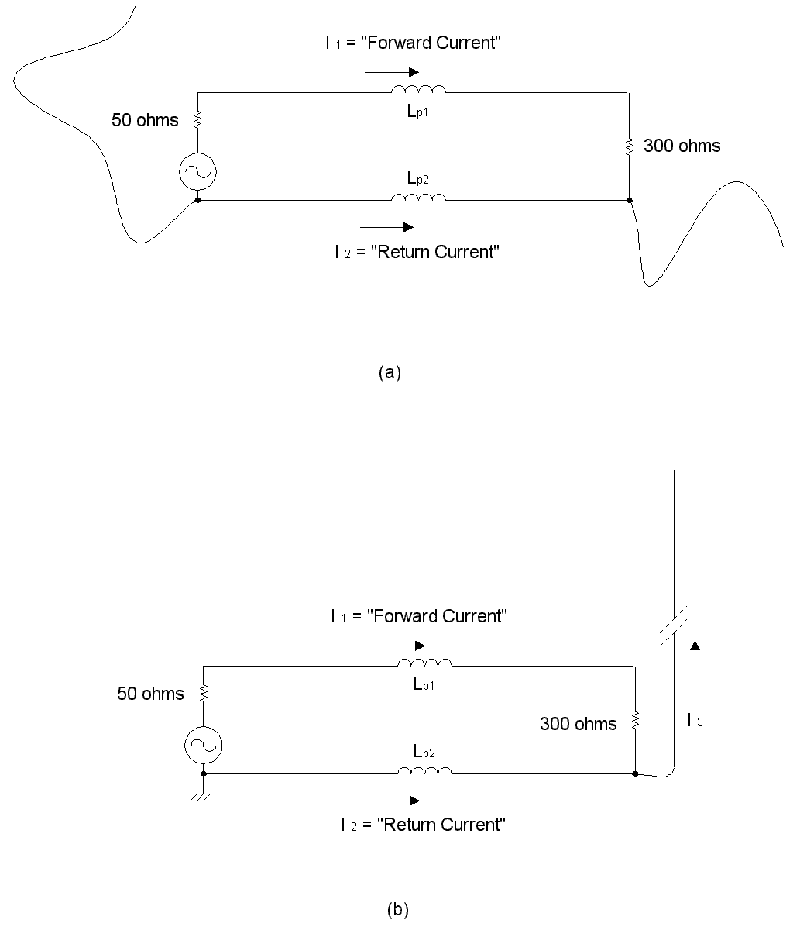
Figure 4: Any I/O cables attached to a circuit are directly or incrementally connected to return wires (or planes). How much radiation results is strongly affected by the length and layout of the attached wires. Even a circuit whose source is bonded to a perfect ground plane will exhibit some radiation.

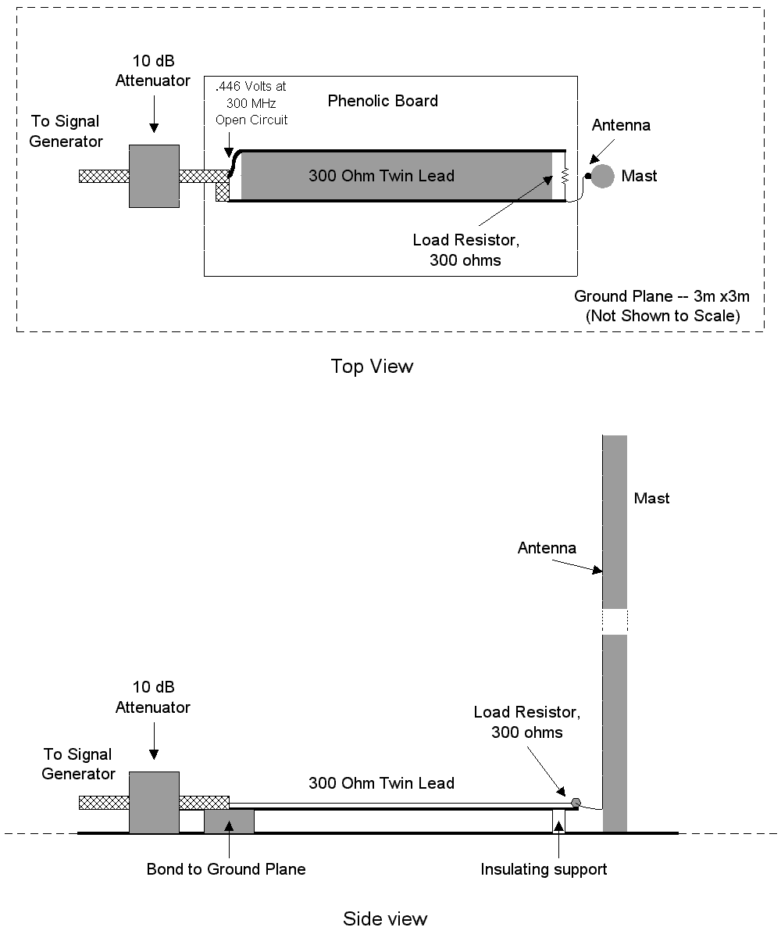
Figure 5: We built this assembly to measure radiation from the circuit shown in Figure 4b.

Digital devices, of course, are far more complex than our simplified model. For one, the various I/O cables (which act as antennas) vary in length and geometry. Any variation in length or geometry quite clearly will affect emissions. Even devices with a good earth ground (such as a solid metal plate beneath the circuit whose smallest dimension is on the order of a wavelength at the lowest frequency of interest) will not necessarily result in lowered emissions. For example, in Figure 4b we show schematically the assembly of Figure 5, one in which one end of our return wire is bolted solidly to our earth ground, and the other end is connected to a wire which is run up a short mast creating a vertical antenna.

We built and tested this assembly. Our assembly consisted of a 50-ohm source driving 300 ohms of twin lead that was terminated in its characteristic impedance. The circuit was suspended .5 inch (1.27 cm) above a large ground plane, and one end of the return wire was bolted to that ground plane. Another wire was connected to the far end of the return wire and run up a short pole, creating the vertical antenna. At resonance, a vertical has one half the impedance of a true dipole, 36.5 ohms. Vertically suspended above a large ground plane, it also produces an image antenna, the net result being a dipole with vertical polarization.

Measurements made with a Tektronix CT1 current probe showed that 1.2 mA of current was flowing into base the vertical wire. Simulations with our Method of Moments software yielded a similar result, 1.34 mA flowing into the base of the vertical wire with predicted field strength of 27,500 uV/m.

Therefore, we can show that even simple circuits, well-matched in terms of their load and suspended a short distance over a wide ground plane can still produce radiation when wires are connected to their return structure. Whether a two-sided or multi-layered board is used, there will always be some partial inductance in the return, and therefore some voltage driving wires attached, even those wires attached to what is sometimes (incorrectly) called “signal ground.”

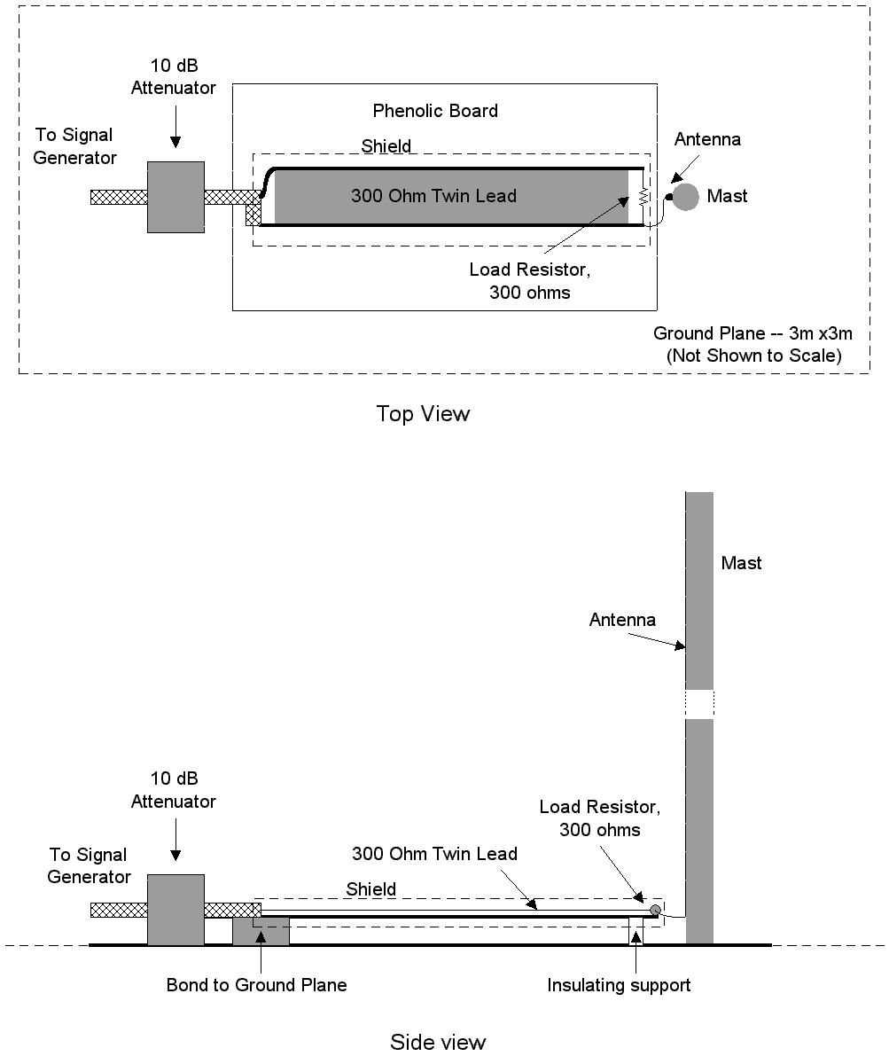
Figure 6: One sure fire way of reducing emissions dramatically is to wrap our circuit in a shield. This forces return currents to flow on the inside of the shield.

How can such radiation be avoided? One method is shown in Figure 6. Here a 360 degree shield has been thrown around our circuit. Note that we have not connected that shield directly to our ground plane, or to any portion of the circuit, except to its return wire. The measured current in the vertical wire falls dramatically -- to 80 uA. The conclusion? Wrapping a complete shield around a circuit will work just about every time.

Why does such a shield work? It works because the return currents travel on the inside of the shield. They don’t travel on the outside of the shield, and therefore, there is no voltage drop between the source and the load. Said another way, a complete shield has a partial return inductance of near zero.

That, in fact, is also why a shielded cable works. The shield formed by the braid or metalized foil traps nearly all the current inside the shield. A perfectly shielded cable has an effective return inductance of zero. However, nothing being perfect, some current does leak through to the surface of a shielded cable. That current produces a small amount of “lost flux,” which, in turn results in a small amount of radiated energy.

How do we use what we have learned in practice? Designers have used two methods to reduce emissions from circuits like that shown in Figure 2 through 4. First, they have abandoned the return wire for the return plane of a multi-layer board. The effective inductance of a plane is far lower than a wire, but is by no means zero. Even in multi-layer boards, significant radiation can result. Wrap a tight shield around the multi-layer board, however, and the radiation will drop dramatically.

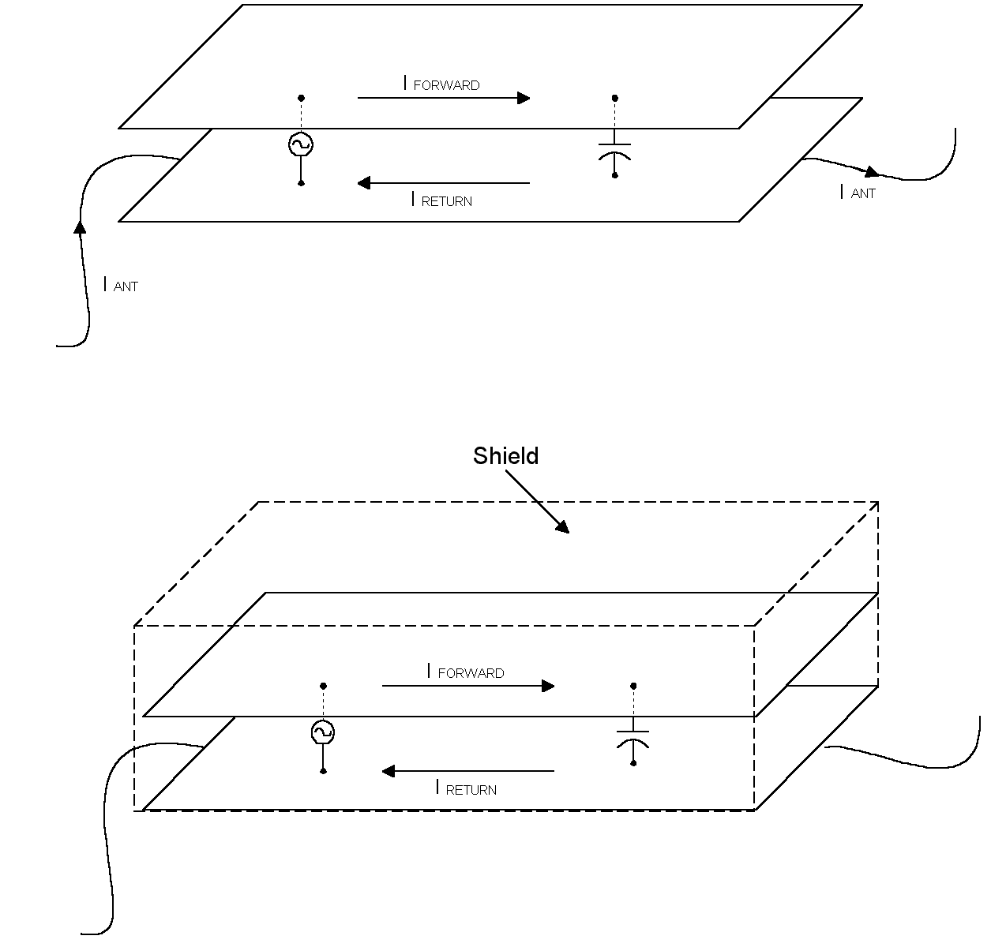
Figure 7: I _{DD} currents drive supply planes as surely as our source in Figure 1 drives its transmission line. Even though the planes are close together, wide and uniform, they still exhibit an effective inductance that causes radiation. The use of planes alone may reduce emissions, but is not as effective a technique as one that would trap returning currents, such as the shield shown at the bottom of the figure.

Sources of RF currents do not refer just to clock drivers and the like. Each time an IC switches, it creates a pulse across its supply. These pulses can be a nanosecond or less in time and tens of amps in amplitude for devices such as a microprocessor. These pulses are referred to as I _{DD} currents or I _{DD} noise. How does I _{DD} noise become common mode radiation? Take a look at Figure 7. In essence it is no different than Figures 1 through 4 except that we have exchanged our 300 ohm twin lead for a transmission line made of plates. Though of lower characteristic impedance, plates form a transmission line nonetheless. Exactly the same effects illustrated above will cause such a circuit to radiate. The extent of the radiation can be calculated if the return plane’s partial inductance is known. From Reference 2, it is:
$$L_{p}=\frac{μ_{0}l}{2}\frac{d}{w}$$
Where:

L _{P} = Partial inductance of the return plane in Henries
μ₀ = 4 π x 10 ⁻⁷
l = Length of the return plane in meters
d = Distance between the planes in meters
w = Width of the planes in meters

That is why the use of a multi-layer board, while in itself a powerful technique for mitigating emissions, is not a perfect solution. In most applications, some other technique has to be used to further lower emissions. This may consist of the use of ferrite cores over I/O cable (which effectively places an impedance in series with the radiation resistance) or the use of a 360 degree shield surrounding the whole circuit to which shielded I/O cables can be attached or unshielded wires bypassed. A complete shield will trap RF currents on the inside, leaving no voltage to cause radiation across its surface.

References

1. EZNEC is available from Roy Lewallen, W7EL@teleport.com.

2. F. Leferink, “Inductance Calculations; Methods and Equations” 1995 IEEE Symposium on Electromagnetic Compatibility, page 16.

