Applying Computational Methods to Test Site and Antenna Design

By Glen Dash, Ampyx LLC, GlenDash at alum.mit.edu
Copyright 2000, 2005 Ampyx LLC

In the past, mathematics and experimentation were the only tools engineers had to understand test site and antenna design. Today we have the Method of Moments.

Antennas commonly used in EMC work include dipole, conical, log periodic and horn types. These are used on calibrated test sites for precision measurements. In the past, engineers had to rely on electromagnetic theory along with good deal of trial and error to design antennas and test sites. Today, we have computational tools that engineers of 30 years ago could only have dreamed of.

In this article, we will apply the elegant and powerful Method of Moments to the design of a half wave dipole and a biconical antenna. We will also use it to derive a site attenuation model. But first we need to review the physics of an antenna that does not, and cannot, exist, yet is the antenna against which all others are measured. It is called the “isotropic radiator.”

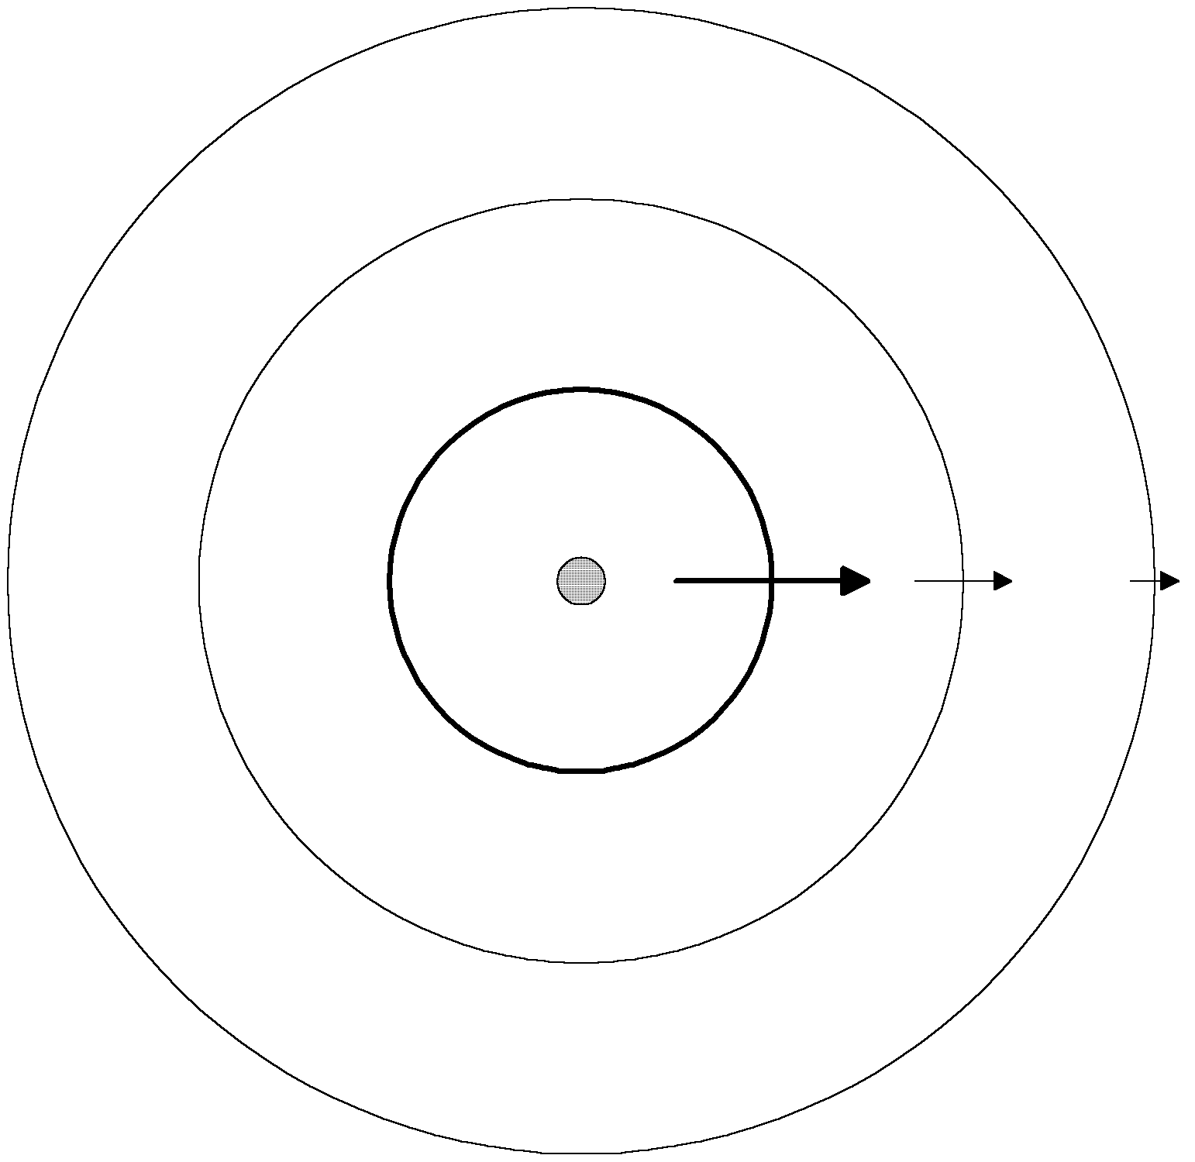
Figure 1: Energy from an isotropic radiator propagates outward evenly in all directions, falling off according to the inverse square law.

An isotropic radiator is an antenna that radiates equally in all directions. An impulse of energy supplied to the antenna’s terminals results in a spherical shell of energy propagating outward at the speed of light. Since energy must be conserved, the shell’s energy per unit area must fall as it expands. In free space, the rate of fall is proportional to 1/4πr².

The purpose of a receiving antenna is to intercept some of this outward radiating energy. For example, consider the case of a theoretical receiving antenna consisting of a one-meter square, perfectly absorbing sheet placed at a distance r from the isotropic radiator. The amount of energy per unit time (power) absorbed by the sheet will be:

$$P_{d}=P_{t}\left(\frac{1}{4{πr}^{2}}\right)$$
Where:
P_{d} = The power absorbed in watts by the 1 meter square sheet (power density)
P_{t} = The power transmitted in watts

The power is transmitted in the form of an electromagnetic field composed of orthogonal electric and magnetic field components. Therefore, the power density incident on our receiving antenna is the cross product of these two fields:

$$P_{d}=E(r)×H(r)$$
Where:
P_{d} = Power density in watts per square meter
E(r) = The electric field at the location of the receiving antenna in volts per meter
H(r) = The magnetic field at the location of the receiving antenna in amperes per meter

Further, in free space the ratio of the two fields is equal to the “free space impedance,” 377 ohms.

$$\begin{aligned}\frac{E(r)}{H(r)}=\text{377} \\ P_{d}=\frac{{\left|E(r)\right|}^{2}}{\text{377}}\end{aligned}$$

Using these relations we can derive an expression for the electric field produced by an isotopic radiator at a given distance r:
$$\begin{aligned}P_{d}=\frac{P_{t}}{4{πr}^{2}} \\ P_{d}=\frac{{\left|E(r)\right|}^{2}}{\text{377}} \\ E(r)=\sqrt{\text{377}⋅P_{d}}=\sqrt{\frac{\text{377}}{4π}}\frac{\sqrt{P_{t}}}{r}=\frac{5\text{.}5}{r}\sqrt{P_{t}}\end{aligned}$$

Note that this relationship is derived purely from the conservation of energy.

The size of the receiving antenna can, of course, be other than 1 square meter. Further, its efficiency may make the antenna seem to be either larger or smaller than its physical size. These factors can be rolled into an “effective area” for an antenna. The amount of power received is the power incident upon an antenna times its effective area. For a 100% efficient 1m² perfectly absorbing sheet, the effective area would be 1. A sheet of .5m² physical size, 50% efficient, would have an effective area of .25.

$$P(r)=P_{d}A_{\text{eff}}=P_{t}\left(\frac{A_{\text{eff}}}{4{πr}^{2}}\right)$$

Where:
P(r)= Power received in watts
A_{eff} = The antenna’s effective area

The receiving antenna is usually designed to convert the received power into a voltage for measurement. Since each antenna will have its own characteristic impedance (a “radiation resistance”), a transfer function can be derived which relates the power incident on the receiving antenna to the voltage at the antenna terminals:

$$\frac{{\left|V_{r}\right|}^{2}}{R_{\text{ant}}}=P(r)=P_{t}\left(\frac{A_{\text{eff}}}{4{πr}^{2}}\right)$$

Where:
V_{r} = The voltage at the receive antenna’s terminals
R_{ant} = The receive antenna’s radiation resistance

A true isotropic radiator really exists only in theory. Practical antenna types commonly used in EMC work include the dipole and biconical types.

The Dipole

Perhaps the simplest practical antenna is the half wave resonant (tuned) dipole. Its pattern is not isotropic. Instead, in the plane of the antenna (the “azimuth”) the electric field it produces is in the shape of a broad figure eight. Transmitted power is focused in the forward and rearward directions. Since energy must be conserved, this means that the dipole exhibits a “power gain over isotropic.” Theory predicts that this power gain is equal to 1.64, or expressed logarithmically, 2.14 dB:

$$G_{i}(\text{dB})=\text{10}\text{log}G_{i}$$
Where:
G_{i}=Power gain over isotropic
G_{i}(dB)=Power gain over isotropic in dBi

We can confirm theory by using the computational Method of Moments. The method is utilized in number of software packages and the one we will use is EZNEC (Reference 5). We will set the frequency to 100 MHz and the length of the antenna to 1.44 meters, which should produce resonance. We will make our theoretical antenna out of #12 AWG copper wire.

EZNEC calculates the antenna’s characteristics, including its azimuth pattern, its gain over isotropic (calculated to be 2.11 dBi) and its input impedance (close to 73 ohms) (Figure 3). The slight difference in gain over isotropic from the theoretical is due to the fact that our antenna is not perfectly resonant, and is built of copper which has some ohmic losses. A gain over isotropic of 2.11 dBi is equal to a power gain of 1.61.

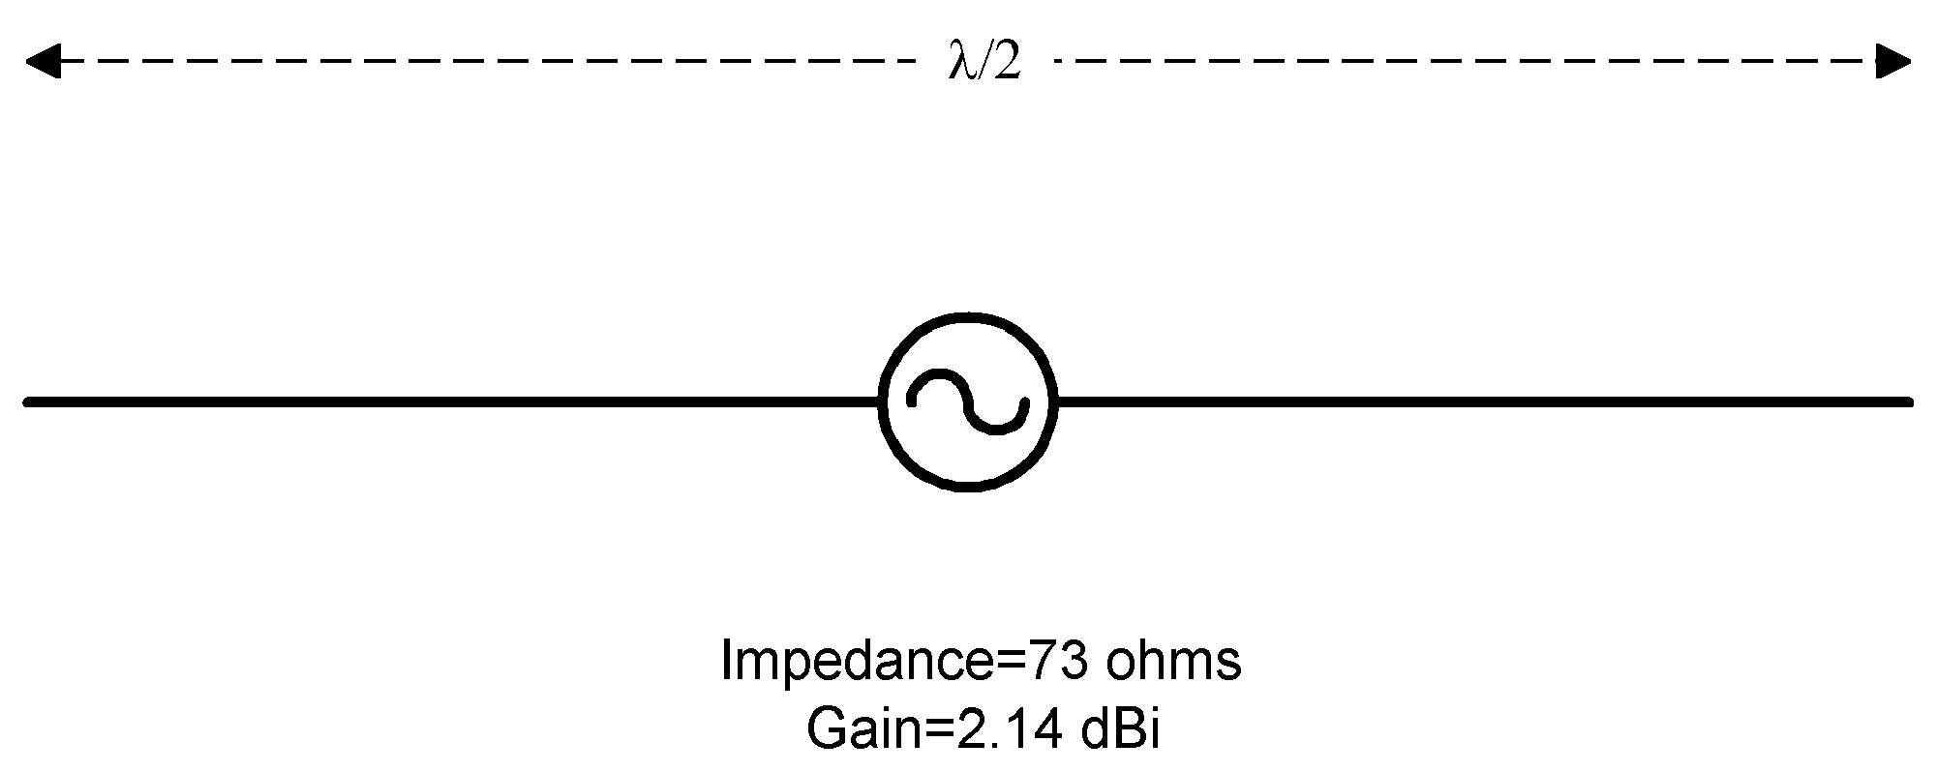

Figure 2: Among the simplest of antennas, the half wave resonant dipole is a good starting point for antenna analysis.

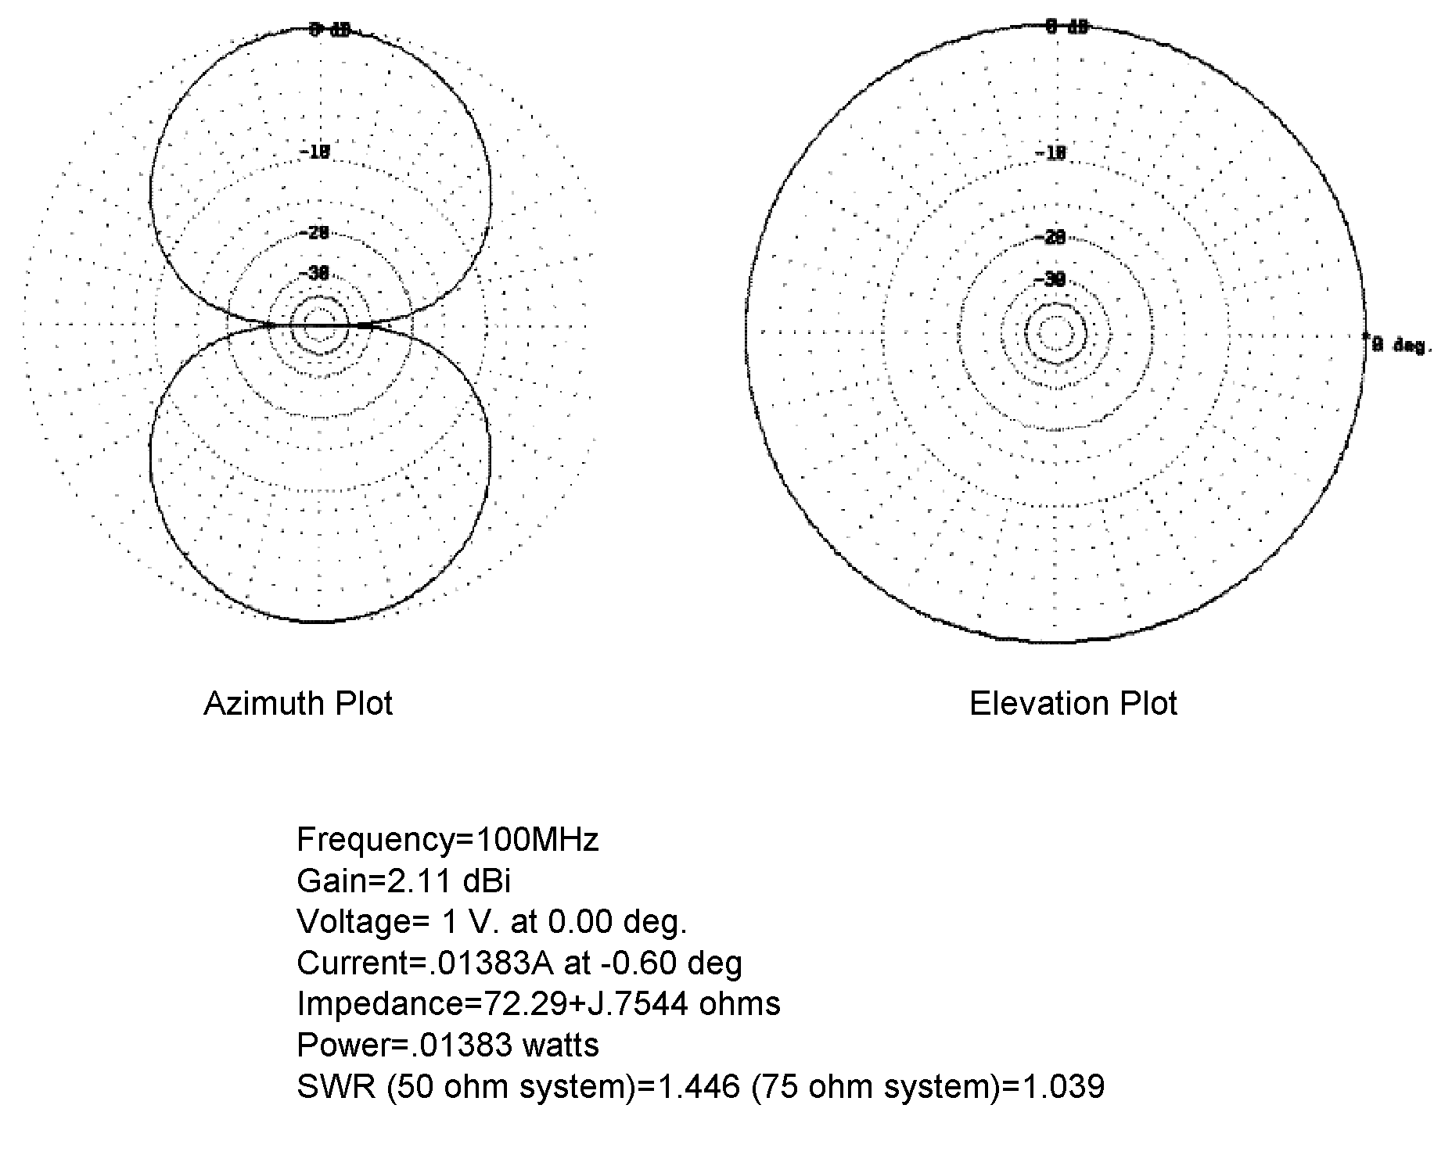
Figure 3: Using a Method of Moments program, we can calculate the azimuth and elevation plots of a half wave, tuned dipole in free space.

Based on this simulation, our half wave tuned dipole will produce a field strength at a given distance r equal to:

$$\begin{aligned}E(r)=\frac{5\text{.}5}{r}\sqrt{G_{i}P_{t}} \\ G_{i}=1\text{.}\text{61} \\ E(r)=\frac{7}{r}\sqrt{P_{t}}\end{aligned}$$

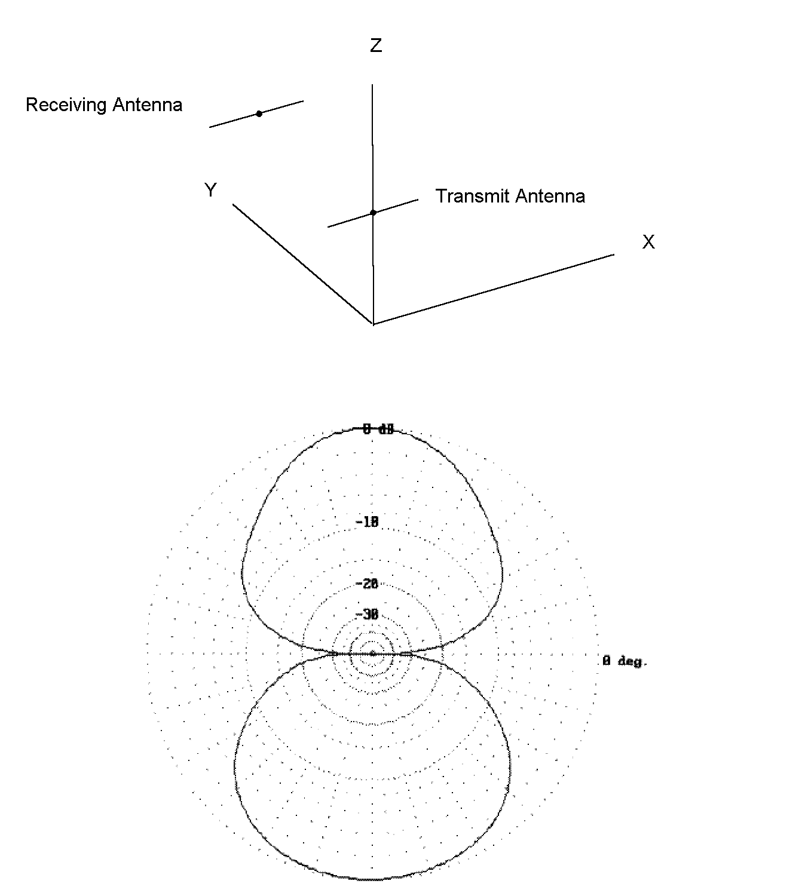
Figure 4: We add a receiving antenna three meters from the transmitting antenna of Figure 3. This allows us to calculate site attenuation. Note that just the presence of the receiving antenna bows out the field slightly.

Using EZNEC, we now add a receiving antenna to the simulation, placing it 3 meters from the transmitting antenna. The antennas are co-planar as shown in Figure 4. EZNEC generates the results shown. Note that the field produced by the transmitting antenna has been distorted somewhat by the presence of the receiving antenna.

According to Reference 2, the effective area of a tuned half wave dipole is:

$$A_{\text{eff}}=\frac{G_{i}λ^{2}}{4π}$$

Therefore, the received power will be:
$$\begin{aligned}P(r)=A_{\text{eff}}\frac{G_{i}P_{t}}{4{πr}^{2}} \\ P(r)=\frac{G_{i^{2}}λ^{2}P_{t}}{\text{16}π^{2}r^{2}} \\ \frac{P(r)}{P_{t}}=\frac{G_{i^{2}}λ^{2}}{\text{16}π^{2}r^{2}}\end{aligned}$$

Since the electric field is proportional to the square root of the power:

$$\frac{E(r)}{E_{t}}=\frac{G_{i}λ}{4πr}=\text{.}\text{13}\frac{λ}{r}$$

Further, since the antennas are identical, the ratio of the voltage driving the transmitting antenna (V_{i}) to that measured at the receiver (V_{r}) will be the same.

$$\frac{V_{r}}{V_{i}}=\text{.}\text{13}\frac{λ}{r}$$

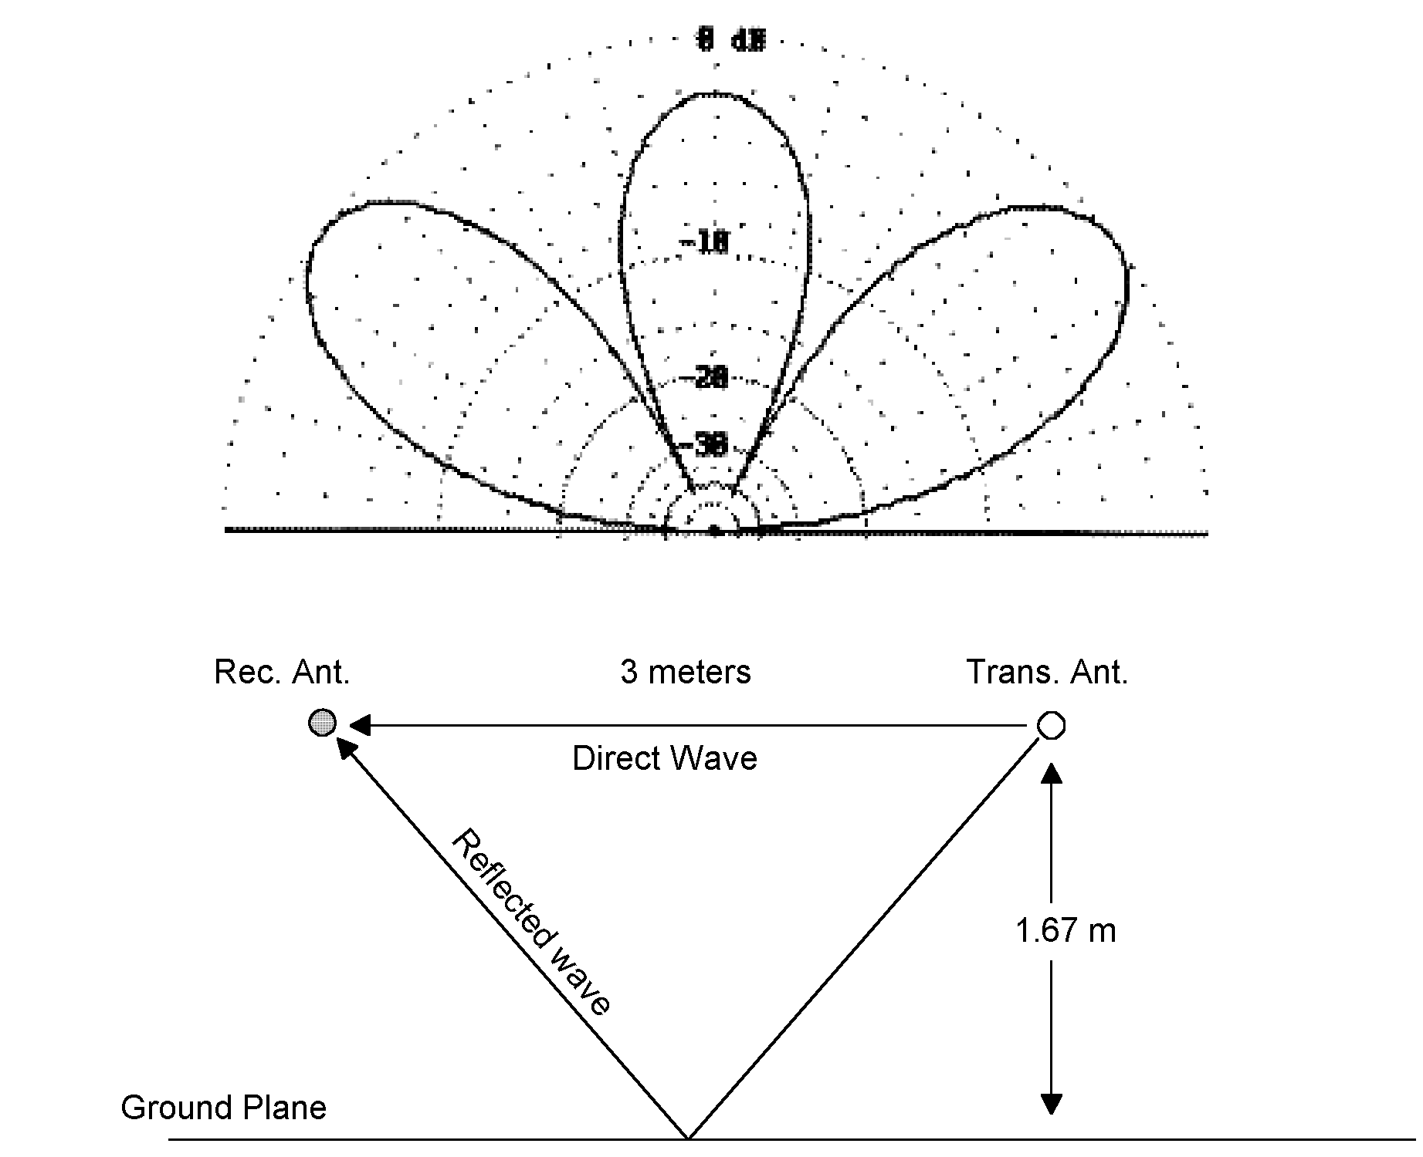
Figure 5: A test site has a ground plane which reflects some of the transmitted signal, causing lobes in the radiated field. The amount of signal received therefore depends on the height of the antennas above the ground plane. The simulation shown is for resonant half wave dipoles operated at 100 MHz.

We now place a perfectly reflecting ground plane 1.67 meters under the two antennas. The effect of the ground plane is to reflect some signal, changing the amount of signal received. The effect can be observed from the EZNEC computed elevation plot shown in Figure 5. (The elevation plot maps the electric field in a plane perpendicular to the ground plane and passing through the center of the transmitting antenna.) The presence of the ground plane causes lobes to be produced. The shape of these lobes is a function of the height of the transmitting antenna above the ground plane and the frequency. For the configuration shown in Figure 5 (which places the receiving antenna in the lobe of maximum reflected signal) the gain in electric field resulting from addition of the ground plane is approximately 1.67.

This increases the ratio of received to transmitted signal:

$$\frac{V_{r}}{V_{i}}=(1\text{.}\text{67})(1\text{.}3)\frac{λ}{r}=\text{.}\text{22}\frac{λ}{r}$$

For example, operating at 100 MHz (λ=3 meters):

$$\frac{V_{r}}{V_{i}}=\text{.}\text{22}$$

That is, if we put 1 volt into the transmitting antenna, .22 volts will be measured on the receiver. The transmission loss, also known as the “site attenuation,” is 13.2 dB.

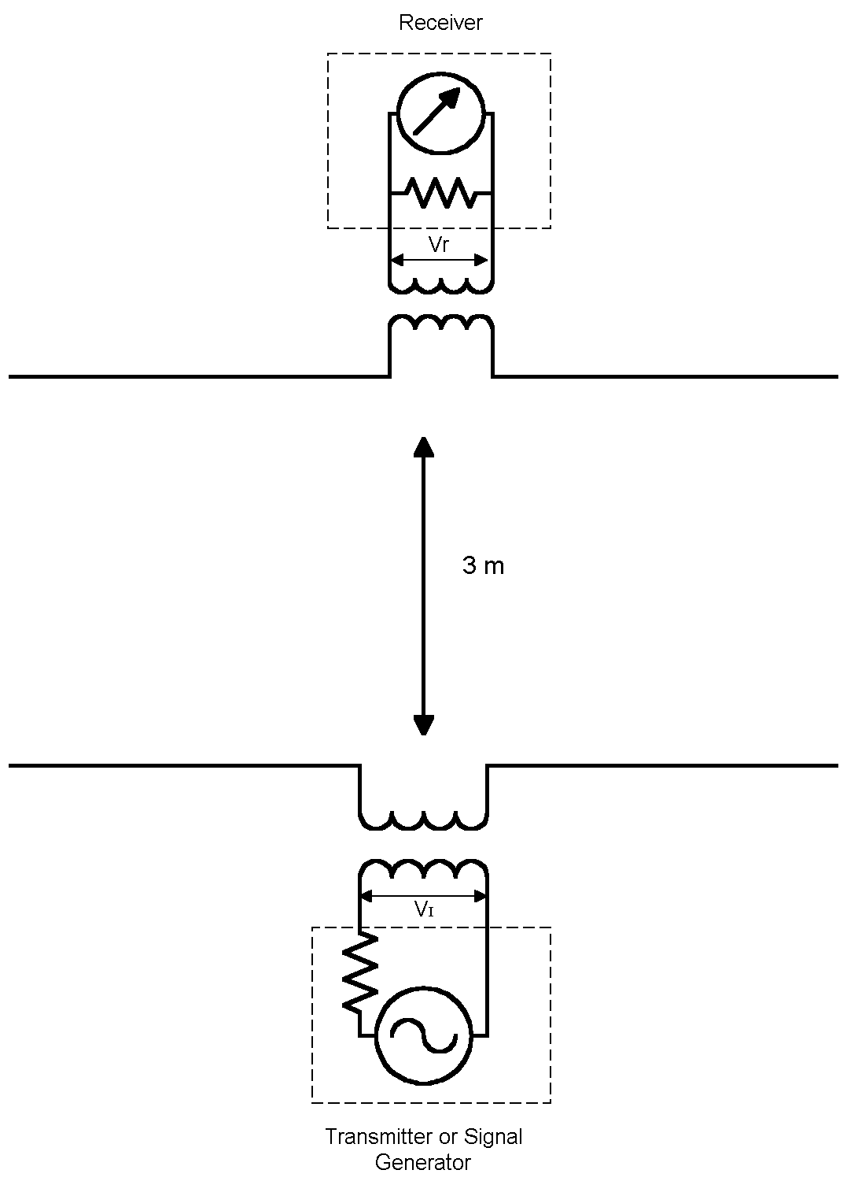
Figure 6: A system consisting of a transmitting and receiving antenna can be modeled as a two-port network. The ratio of signal out (V_{r}) to the signal in (V_{I}) is known as the site attenuation.

We will also find it useful to calculate the electric field incident on the receiving antenna from the voltage observed on a receiver:
$$\begin{aligned}P(r)=P_{d}A_{\text{eff}}=P_{d}\frac{G_{i}λ^{2}}{4π} \\ P_{d}=\frac{{\left|E(r)\right|}^{2}}{\text{377}} \\ P(r)=\frac{{\left|E(r)\right|}^{2}G_{i}λ^{2}}{\text{377}⋅4π}\end{aligned}$$

Therefore, the voltage at the receiver input will be:

$$\begin{aligned}\frac{{\left|V_{0}\right|}^{2}}{\text{50}}=P(r)=\frac{{\left|E(r)\right|}^{2}G_{i}λ^{2}}{\text{377}⋅4π} \\ V_{0}=E(r)λ\sqrt{\frac{1\text{.}\text{64}⋅\text{50}}{\text{377}⋅4π}}=\text{.}\text{132}E(r)λ \\ λ=\frac{\text{300}}{f_{\text{MHz}}} \\ V_{0}=\text{39}\text{.}6\frac{E(r)}{f_{\text{MHz}}} \\ E(r)=\frac{1}{\text{39}\text{.}6}V_{0}f_{\text{MHz}}\end{aligned}$$

Where:

f_{MHz} = Frequency in MHz.

This equation is usually written in its logarithmic form:

$$\begin{aligned}E(r)=\frac{1}{\text{39}\text{.}6}V_{0}f_{\text{MHz}} \\ E(\text{dB})=\text{20}\text{log}E(r) \\ V_{0}(\text{dB})=\text{20}\text{log}V_{0} \\ E(\text{dB})=V_{0}(\text{dB})+\text{20}\text{log}f_{\text{MHz}}−\text{31}\text{.}9 \\ \text{Let }\text{AF}=\text{20}\text{log}f_{\text{MHz}}−\text{31}\text{.}9 \\ E(\text{dB})=V_{0}(\text{dB})+\text{AF}\end{aligned}$$

The term AF is known as the antenna factor. By adding the antenna factor to the voltage observed on the receiver, the electric field incident on the antenna can be calculated. For a perfect half wave tuned dipole, the antenna factor is:

$$\begin{aligned}\text{AF}=\text{20}\text{log}\left(\frac{f_{\text{MHz}}}{\text{300}}\sqrt{\frac{\text{377}⋅4π}{\text{50}⋅G_{i}}}\right)=\text{20}\text{log}f_{\text{MHz}}−\text{31}\text{.}9 \\ E(\text{dB})=V_{0}(\text{dB})+\text{AF}\end{aligned}$$

The method also works for antennas of the biconical and log periodic type, though for those antennas the antenna factor must be generally be derived empirically.

Site Attenuation

The fact that the transmission loss between a transmitting and receiving antenna can be so readily predicted means that a test can be devised to measure the quality of test sites. In the 1950’s, the Federal Communication Commission (FCC) began to develop such a test based on the site attenuation principle. Figure 7 shows a typical test site. The receiving antenna can be raised or lowered over a 1 to 4 meter range in order to pick up the lobe of maximum emissions. The transmitting antenna is fixed at a height of two meters. Both antennas are horizontal.
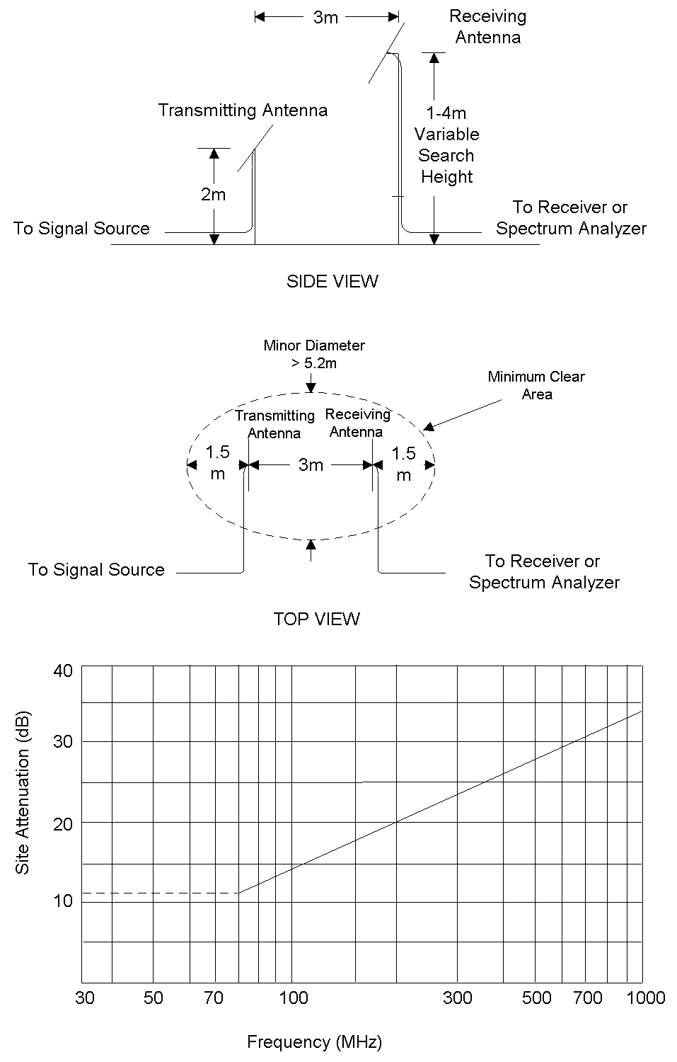
Figure 7: Site attenuation is illustrated. Two dipole antennas are placed three meters apart. The transmitting antenna is horizontal and is fixed two meters above the ground plane. The receiving antenna is three meters away and can be raised or lowered through a distance of one to four meters. The minimum loss at each frequency should follow the curve shown. The solid portion of the curve is derived theoretically, the dotted portion empirically.

Using the analysis above, and assuming that each antenna adds .5dB of loss, the site attenuation should be:

$$\text{SA}=\text{20}\text{log}f_{\text{MHz}}−\text{25}\text{.}7$$

Thus, at 100 MHz the site attenuation should be 14.3 dB.

This equation was incorporated in FCC Bulletin OST-55. The equation works well only above 80 MHz due to the restricted height of the receiving antenna. Below that frequency, OST-55 required test sites to meet an empirical curve.

In the 1980’s, ANSI Accredited Standards Committee C63 developed a more general test for site attenuation. In addition to specifying site attenuation tests for 3, 10 and 30 meter test sites in both vertical and horizontal polarization, the standard is flexible enough to be used with any well calibrated, linearly polarized antenna.

The Biconical

The use of conical antennas goes back to the dawn of the radio age. In the early 1900’s, Marconi found that a conical antenna produced better results than a single wire and built transmitting antennas using conical designs.

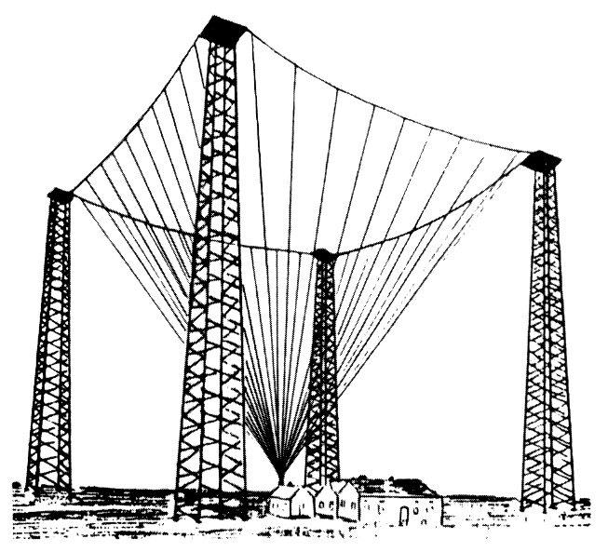
Figure 8: Marconi’s Poldhu station in England (1905). Although generally not appreciated at the time, the conical design of the antenna was a key to its success. After Reference 4.

The reason that conical antennas proved superior was that Marconi’s spark transmitter was a broadband source. When combined it with a broadband antenna, Marconi was able to transmit far more energy than he could of have had he been limited to the resonant frequency of a single wire.

Marconi’s antenna was known as a discone, a cone shaped structure placed vertically over a ground plane. Combining two such cones back to back produces a bi-conical antenna. Though the general characteristics of conical antennas have been known for almost a century, precise mathematical models predicting their behavior proved illusive. Prior to the development of computational techniques, researchers had to rely mostly on experimental data to design their discone or biconical antennas.

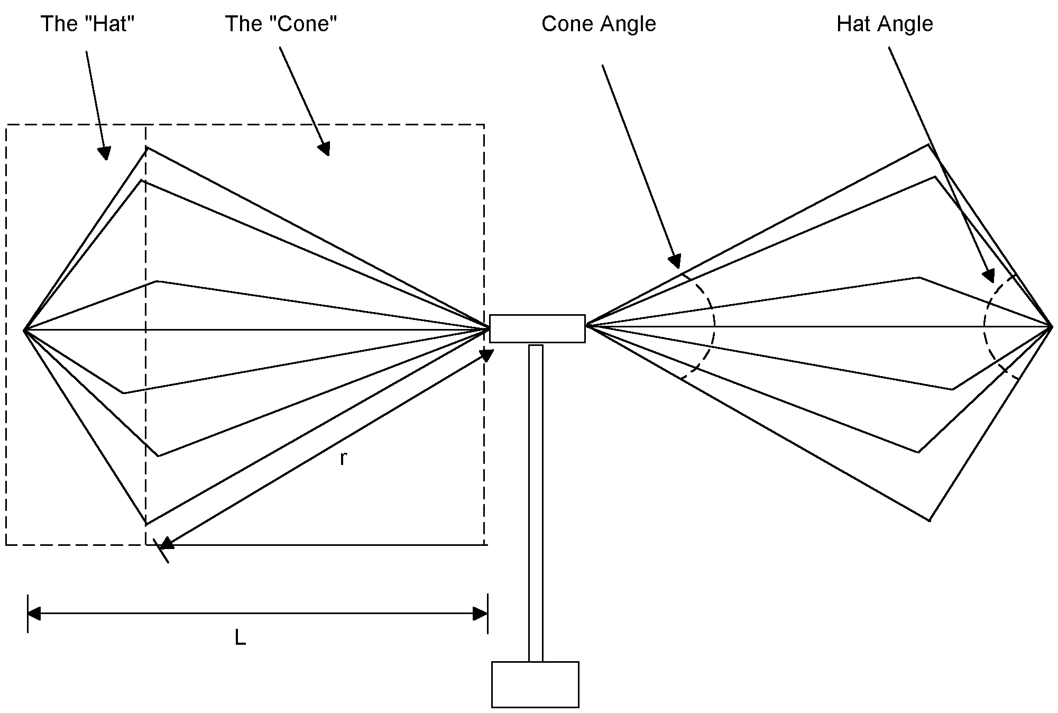
Figure 9: A typical biconical antenna used for EMC work. Key parameters are the cone length (r), the overall length (L) and the angle formed by the cone and the hat.

Some of that data is shown in Figure 10. At resonance, the impedance of a discone antenna is a function of its cone angle. Note that at a given cone angle the impedance is relatively flat over a wide frequency range. Further, the azimuth pattern of a discone antenna is a broad figure eight, just like a dipole, and it retains this shape over a wide frequency range. The relatively flat impedance combined with the relatively stable azimuth pattern makes the discone antenna an ideal choice for broadband transmission.

The same is true for the biconical antenna. Since the biconical antenna is made up of two discones back to back, impedance curves for the biconical antenna can be derived simply by multiplying the curves in the Figure 10 by two.

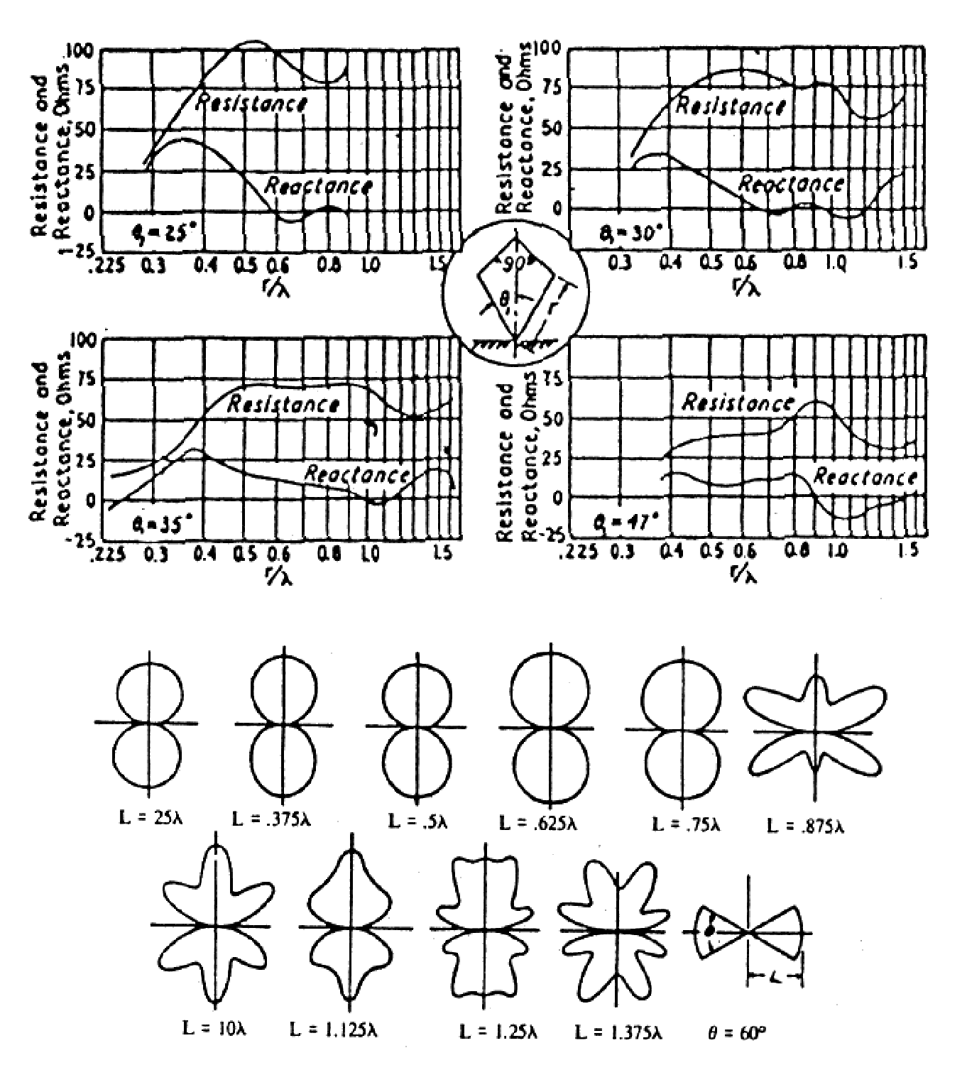
Figure 10: Before the advent of computerized methods, conical antennas were designed using empirically derived charts and tables, such as those shown here. The key to the biconical’s unusual characteristics is its relatively flat impedance and it dipole like azimuth pattern. After Reference 1.

The biconical style antenna commonly used for EMC testing uses a cone made of six to eight individual rods. The rods are tied together at the antenna’s extremities by bending them into a “hat.” As a practical matter, the hat has only a minor effect on performance. These antennas have reasonably good performance from 60 to about 200 MHz. Below 60 MHz antenna’s SWR becomes high. The antenna is simply too short to exhibit a good impedance match at low frequencies. Rather than behaving as a biconical antenna, it is simply a short, fat, mismatched dipole. To have low SWR, the ratio of r to λ should be greater than .25. To preserve a good azimuth pattern the ratio of L to λ should be less than .75 (Figure 10).

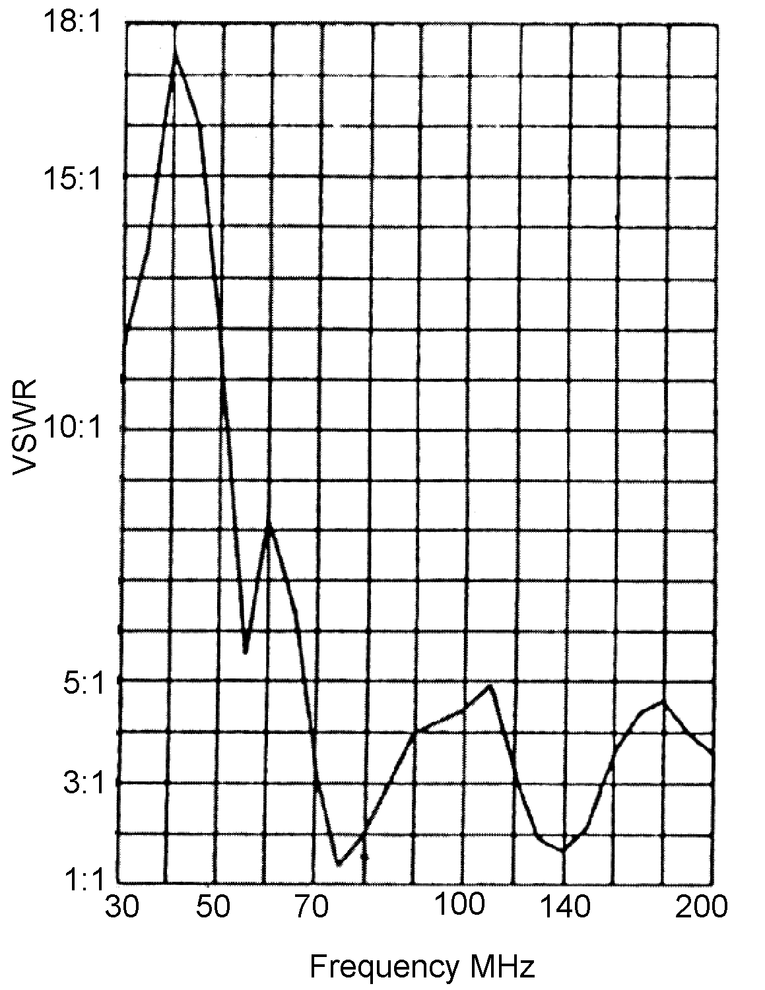
Figure 11: Widely used for EMC work, the typical biconical antenna exhibits high SWR below 60 MHz. It is simply too short to be well matched there. Still, the antenna can be used if well calibrated. After Reference 3.

In recent years, manufacturers have attempted to deal with the low frequency performance issues of the biconical antenna through the use of loading elements placed at either end of the antenna. This can improve performance somewhat.

We can use the Method of Moments to simulate a biconical antenna. The design we chose to model is simple, consisting of 4 rods simulating each cone. Like commercially available antennas, our biconical works reasonably well above 60 MHz. For antennas used in free space, only a minimal number of rods are needed. However, nearby structures such as the feed line or a ground plane can imbalance the antenna, so for practical applications more rods are needed. Where severe loading is expected, solid cones may be required.

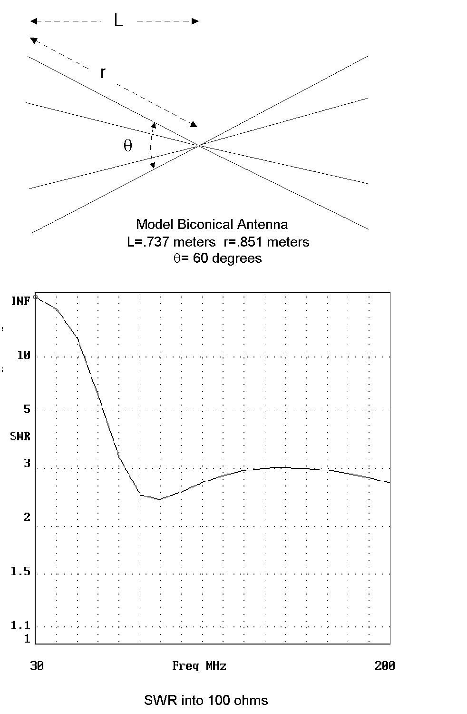
Figure 12: We designed our own biconical antenna and tested it using the Method of Moments. With L=.737 meters and θ=60 degrees, the antenna works well from 60 MHz to over 200 MHz. At the low end, SWR rises, as it does for most practical biconical designs. SWR shown is into 100 ohms.

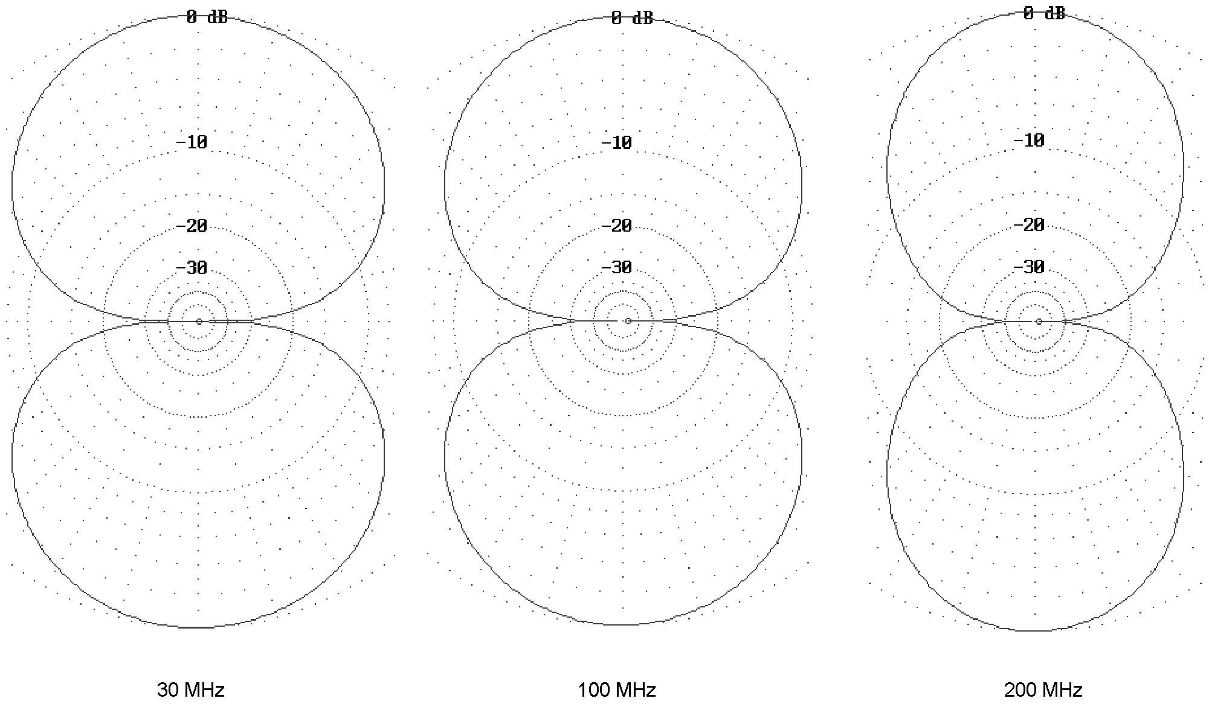
Figure 13: Azimuth patterns for our model biconical antenna are shown.

References:

- Very High Frequency Techniques, Radio Research Laboratory of Harvard University, Volume I, Chapter 4, McGraw Hill (1947).
- W. K. Roberts, A Guide to FCC Equipment Authorizations, published by Willmar K. Roberts, (1980).
- I. Straus, “A New Biconical Antenna For Use in the Frequency Range of 175 to 1000 Megahertz,” ITEM (1985).
- J. Kraus, Antennas, McGraw Hill (1988).
- EZNEC is available from Roy Lewallen, W7EL, P.O. Box 6658, Beaverton, OR 97007. For this article, EZNEC 2.0 was used.

We will be assuming here that the distance r is greater than λ/2π (far field).

