Circuit Models Make Shield Design Simple

By Glen Dash, Ampyx LLC, GlenDash at alum.mit.edu
Copyright 1997, 2006 Ampyx LLC

Inadvertent magnetic and electric field coupling among circuits limits the dynamic range of amplifiers, lowers noise margins and creates unwanted noise. While every engineer know that shielding can prevent coupling, for many shielding is a vaguely understood concept. Perhaps part of the reason is the way that shielding concepts are traditionally taught – physicist’s concept of fields and flux is usually used. It is possible however to explain shielding theory using more familiar circuit concepts.

For example, Figure 1(a) shows a circuit in which an alternating current electric field is created between two plates called the “source” and “receptor” plates respectively. A voltage source is shown connected to the source plate through impedance Z₁. The electric field produced is coupled capacitively to the receptor plate. Coupled voltages create coupled currents which flow through Z₂.

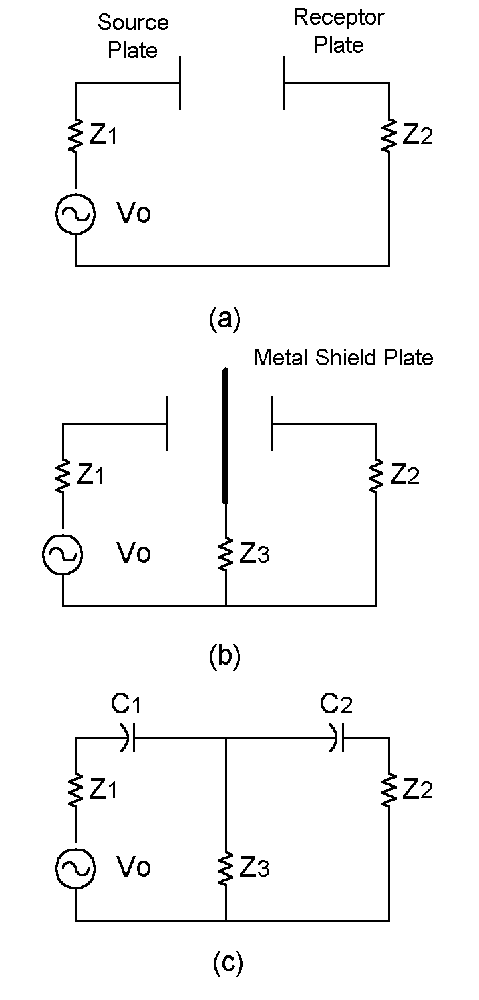
Figure 1: Electric field coupling is capacitive in nature. Placing a metal plate between the source and receptor interrupts the capacitive coupling. To be effective the shield plate must be large enough to intercept substantially all the flux generated by the source and must be connected to either the source or receptor circuit through a low impedance connection.

We can provide a shield by placing a metal plate between the two plates as shown in Figure 1(b). If the plate is large enough it will intercept the bulk of the electric field lines between source and receptor plates. The circuit equivalent is shown in Figure 1(c). If impedance Z₃ is low enough, little voltage will be transmitted from the voltage source to the load Z₂.

For electric shielding to be effective two factors must be present. First, as noted, the shield has to be physically large enough to intercept most of the flux between source and receptor. A shield completely surrounding the source or receptor works best. Partial shields like that shown in Figure 1(b) can often be effective, but must be connected to either the source or a load return to work. Secondly, impedance Z₃ has to be small enough to shunt currents away from the load.

Magnetic shielding operates through a different principle illustrated in Figure 2(b). There a highly conductive metal plate is placed between a source and receptor coil. The changing magnetic flux created by the source coil creates circulating currents in the shield known as eddy currents. If the shield is conductive enough, the frequency high enough, and shield large enough, these eddy currents will cancel the source field at the shield’s surface. The “skin effect” keeps the magnetic field from penetrating very far into the shield.

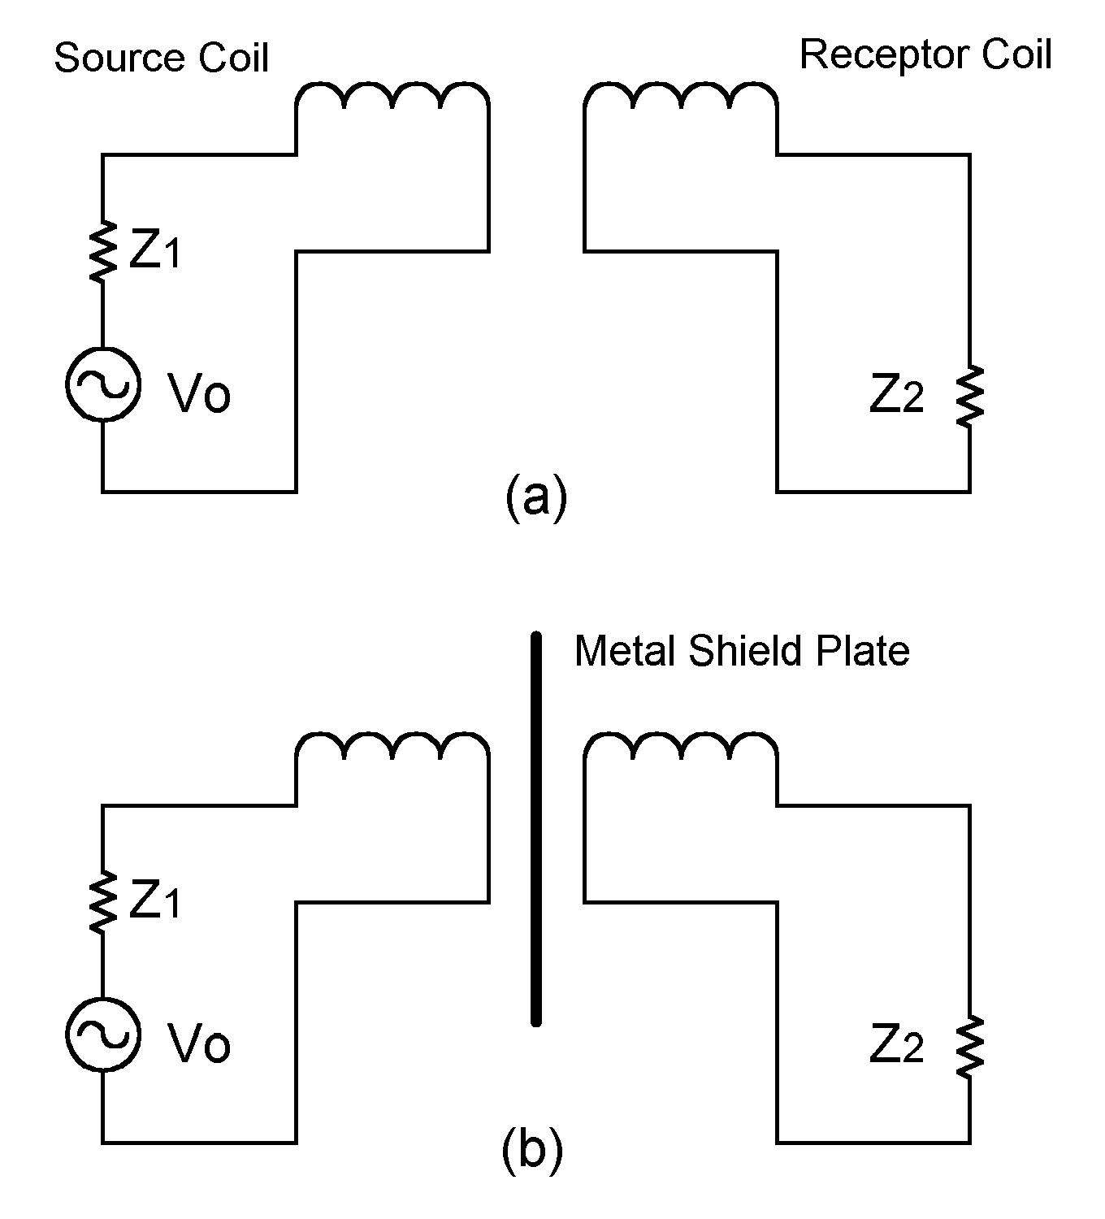

Figure 2: This magnetic field shield relies on the generation of eddy currents within the metal plate to cancel the source field at its surface and prevent it from coupling to the receptor coil.

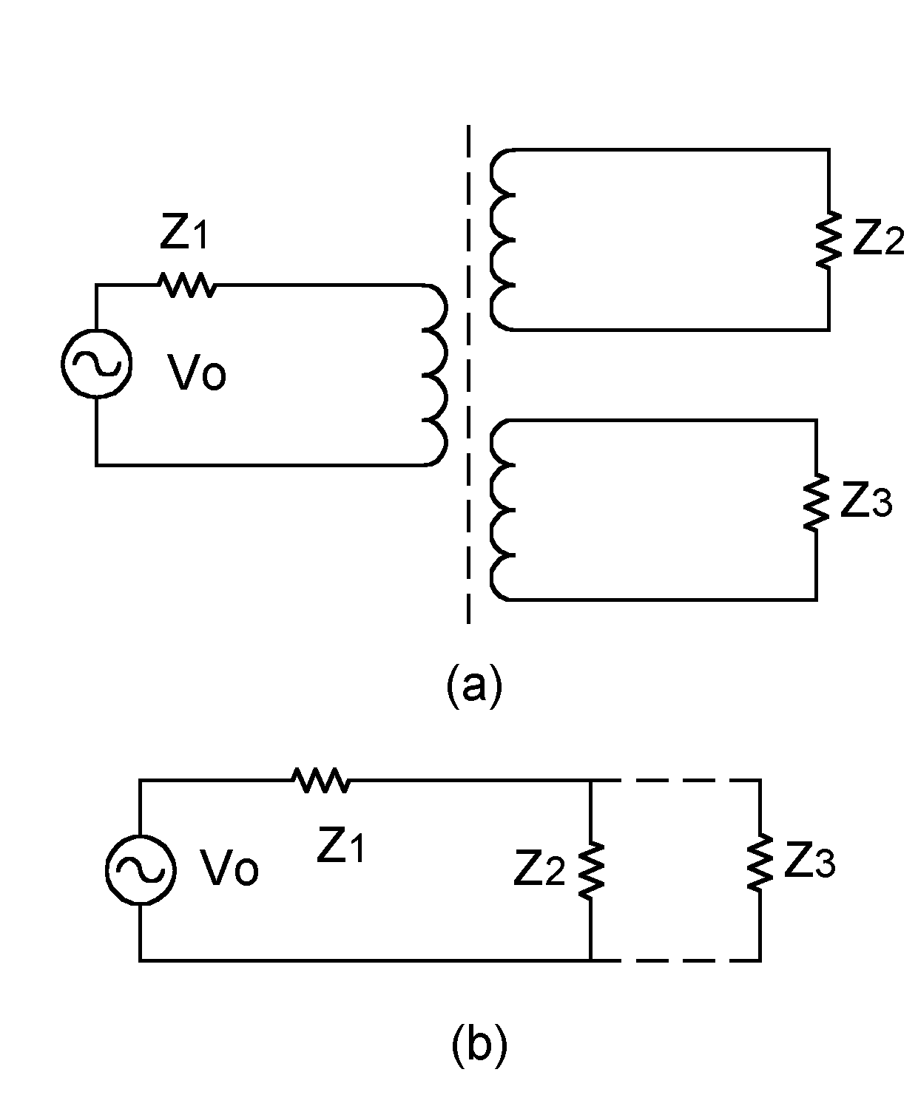

Figure 3: The magnetic field shielding employed in Figure 2 can be understood using the “shorted secondary” concept.

The circuit equivalent is shown in Figure 3. The shield can be thought of as a kind of shorted secondary, shorting out signals that otherwise would be coupled to the load, Z₂.

To be effective, magnetic field shields of this type must be large enough to intercept substantially all the lines of flux between source and receptor. They also must have low impedance. For example, if the shield in Figure 2(b) was split down the middle there would very little shielding effect. Currents attempting to circulate would not be able to cross the split portion of the shield and would not be able to create a magnetic field sufficient to cancel the source field at its surface. This would be equivalent to replacing Z₃ in Figure 3 with an open circuit. Anything which raises the surface resistivity or increases the inductance of the shield will also limit its effectiveness. Along with splits in the shield, long thin gaps in the shield can have this effect.

As with electric field shields, best performance requires a shield that completely encloses the source or receptor. However, as the circuit models make clear, magnetic shields do not have to be connected back to the source or load to be effective unless, as described below, such connections are required to provide the complete current loop needed for flux cancellation.

The application of these principles to wire shielding is illustrated in Figure 4. Figure 4(a) shows two wires over a common ground plane. Currents in the source wire can couple electrically (capacitively) and magnetically (inductively) to the receptor wire. To provide for electric field shielding it is only necessary for the shield over the receptor wire to be connected to a return at one end. To provide magnetic shielding, however, connections at both ends are required in order to provide for the “shorted secondary” effect.

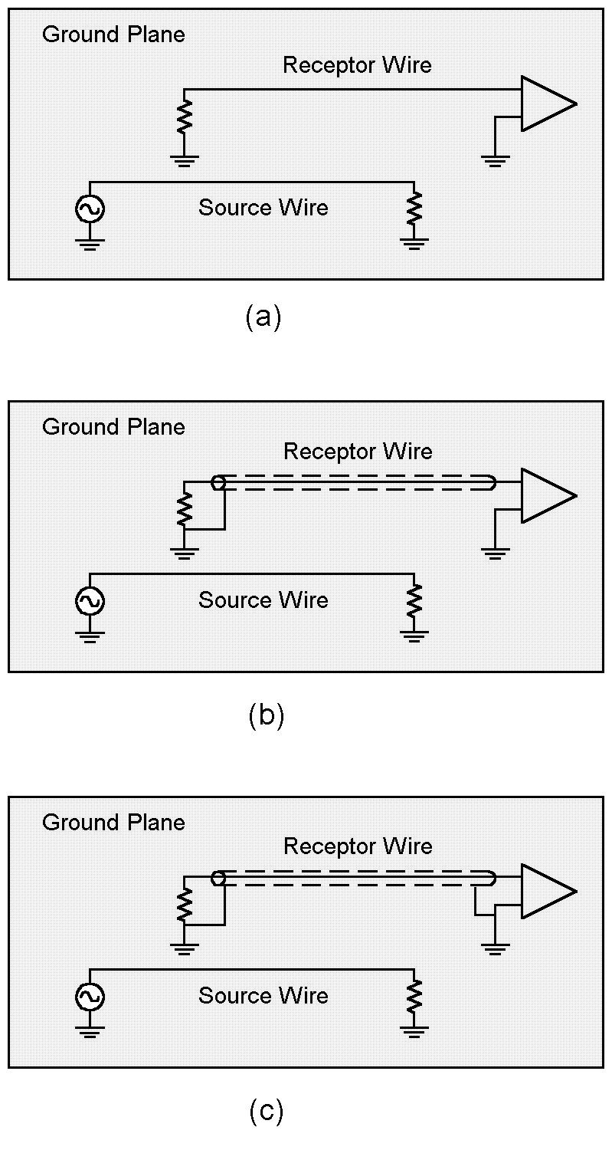

Figure 4: Here we apply the principals of electric and magnetic shielding to the case of a wire suspended over a return plane. An electric field shield only requires a grounded connection at one end, whereas a magnetic field shield must be connected at both ends to be effective.

Keep in mind that we are dealing with near field effects here. Circuit models of this sort are really only useful when the source and receptor are near one another. Where they are not, simple plates will rarely do the job -- far fields just bend right around them. For effective far field shielding, one really has no choice but to completely enclose the source or receptor in a conductive box.

